Frederick Douglass Abolitionist
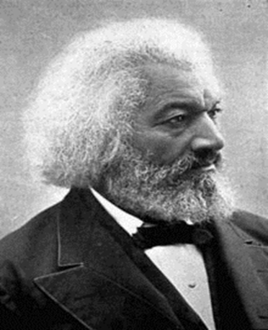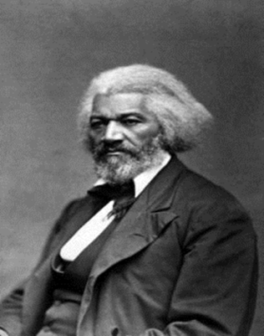
Life as a Slave
- Frederick Douglass, was born a slave in ________________________sometime between 1816 to 1818.
- He was separated from his mother, Harriet Bailey, when he was still an infant.
- She died when Douglass was about 7.
- When Douglass was about 12, his owner’s wife broke the law by ______________________________________________________________________________.
- Douglass succeeded in learning to read from ____________________ in the neighborhood in which he lived, and by _____________________the writings of the men with whom he worked.
- When his owner discovered he could read, he strongly _________________, saying that if a slave learned to read, he would become dissatisfied with his ___________________________
________________________________________.
- At the age of 15, Frederick was sent to a poor farmer who had a reputation as a _____________
__________________________ where Douglass was whipped regularly.
From Slavery to Freedom
- Douglass successfully ________________ slavery on September 3, 1838, boarding a train to Maryland, dressed in a sailor's uniform and carrying identification papers provided by a free black seaman.
- His escape to freedom eventually led him to New York, the entire journey taking less than 24 hours.
- Douglass _________________won his freedom when British sympathizers paid the slaveholder who legally still owned him.
- Douglass joined various organizations including a black church, and regularly attended abolitionist meetings.
- Douglass was inspired by ______________________________________, an abolitionist and publisher of _________________________________, an abolitionist newspaper.

Life After Slavery
- Douglass heard Garrison speak at a meeting of the ____________________________________.
- Douglass was unexpectedly asked to speak at one of these meetings, where he told his story and was encouraged to become an ____________________________________________________.
- He was 23 years old.
- He was acquainted with the radical abolitionist ___________________________but disapproved of Brown's plan to start an ______________________ slave rebellion in the South.
- Brown visited Douglass' home two months before he led the raid in ______________________.
Meeting the President
- Douglass met with________________________________ in 1863 on the treatment of black soldiers, and with President Andrew Johnson on the subject of __________________________.
- ____________________________ is the civil right to vote, or the exercise of that right.
- Douglass also wanted equality for his people as well. He and Lincoln worked together providing plans to move _________________________________ out of the South once the war was over.
Lincoln’s Memorial
- At Abraham Lincoln's memorial service, Douglass was in the audience.
- Douglass was asked by the people to stand up and speak.
- With no preparation, he gave a fantastic tribute to the President for which he received much respect. The crowd gave him a standing ovation.
Working with the President
- In 1868, Douglass supported the presidential campaign of ______________________________.
- The ____________________________was signed into law by President Grant.
- Under Grant’s leadership, over 5,000 arrests were made and the _________________________ was dealt a serious blow.
- Grant's determination in disrupting the _______________ made him ________________ among many whites, but Frederick Douglass praised him.

