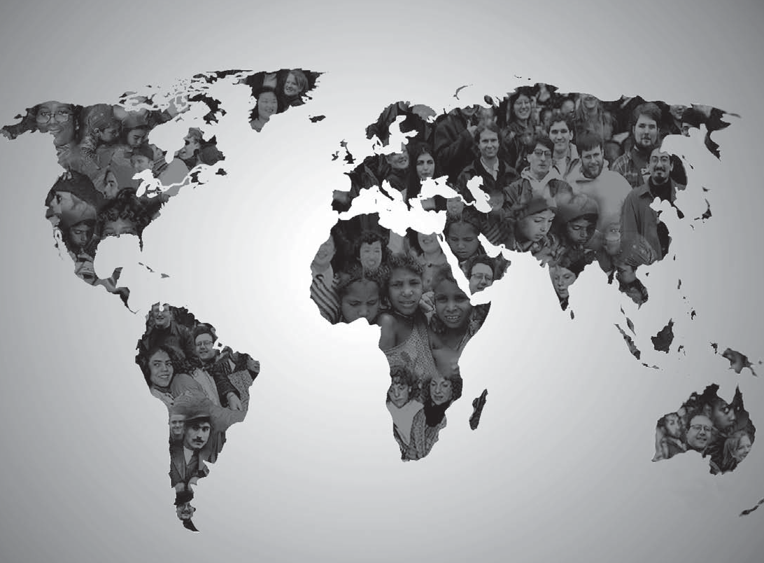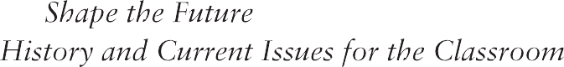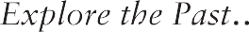

The U.S. Role in a Changing World

CHOICES
for the 21st Century Education Program

January 2008
Director

Susan Graseck

Curriculum Editor

Andy Blackadar

Curriculum Writer

Sarah Kreckel

Office Manager

Anne Campau Prout

Outreach Coordinator

Jillian McGuire

Professional Development Director

Mollie Hackett

Program Associate

Sarah Massey

Staff Associate

Jessica de la Cruz
Videographer/Editor

Julia Liu

The Choices for the 21st Century Education Program develops cur- ricula on current and historical international issues and offers workshops, institutes, and in- service programs for high school teachers. Course materials place special emphasis on the impor- tance of educating students in their participatory role as citizens.
The Choices for the 21st Century Education Program is a program of the Thomas J. Watson Jr. Institute for International Studies
at Brown University.
Barbara Stallings Director, Watson Institute for International Studies

Acknowledgments
The U.S. Role in a Changing World was developed by the Choices for the 21st Century Education Program with the assistance
of the research staff of the Watson Institute for International Studies, scholars at Brown University, and several other experts in the field. We wish to thank the following researchers for their invaluable input:
Thomas Biersteker
Henry R. Luce Professor of Transnational Organizations Department of Political Science, Brown University

James G. Blight
Professor (Research)
Watson Institute for International Studies, Brown University

Neta Crawford
Professor of Political Science and African American Studies Boston University

- Terrence Hopmann
Professor of Political Science
Watson Institute for International Studies, Brown University

janet Lang
Adjunct Assistant Professor (Research)
Watson Institute for International Studies, Brown University

Linda B. Miller
Professor of Political Science, Emerita, Wellesley College Adjunct Professor of International Studies (Research) Watson Institute for International Studies, Brown University

Charles Neu
Professor Emeritus of History Brown University

Janet Sturgeon
Professor, Department of Geography Simon Fraser University

Nina Tannenwald
Joukowsky Family Associate Professor (Research)
Watson Institute for International Studies, Brown University

Kay Warren
Tillinghast Professor in International Studies and Professor of Anthropology Director, Politics, Culture and Identity Program
Watson Institute for International Studies, Brown University

We wish to thank the Carnegie Corporation of New York for its generous support of this unit. The statements made and views expressed are solely the responsibility of the author.
The U.S. Role in a Changing World is part of a continuing series on public policy issues. New units are published each academic year, and all units are updated regularly.
Visit us on the World Wide Web — www.choices.edu

Introduction: A Changing World

n September 11, 2001, terrorists from the al Qaeda terrorist group crashed pas-
O
senger jets into the World Trade Center, the Pentagon, and a field in Pennsylvania. Thou- sands died. Al Qaeda’s leader, Osama bin Laden, chose this way to express his hatred of the United States and its role in world affairs.
In early 2007, the tiny nation of Slovenia, a former communist state, became president of the twenty-seven member European Union, the largest international capitalist network in the world. Indeed, in the last few years several states and satellites of the former communist- ruled Soviet Union have became members of the European Union, exemplifying the spread of Western economic and political structures to more and more countries around the globe.
It is clear that not all the peoples and governments of the world have entered the twenty-first century on the same path. On the one hand, much of the planet seems increas- ingly connected by a web of trade, technology, and common political values. In this age of increasing globalization, traditional divid-
ing lines based on borders and cultures have blurred. On the other hand, the problems that have haunted humanity for hundreds of years have not disappeared. Violence continues to erupt over questions of land, power, and iden- tity. Billions of people live in grinding poverty. Tyrannical governments use fear and intimi- dation to maintain their authority. Today the United States finds itself a part of this complex environment where a host of social and politi- cal systems mingle and clash.
From the first days of the republic, Americans have debated how to balance our priorities at home with our involvement in international affairs. In his farewell address of 1796, President George Washington warned
Americans to “steer clear of permanent alli- ances with any portion of the foreign world.” Yet Washington also recognized that the United States would need to be connected to the larger world in order to prosper.
As we continue to wrestle with the task of balancing domestic needs and international relationships, today’s globalized world con- fronts us with an array of economic, political, cultural, and social concerns. It is important to consider these issues in the context of the values that shape our nation. Values inform policy, and policies, in turn, direct actions.
America was founded on the ideals of democ- racy, equality, and freedom. As the world has changed, our interpretation of these ideals has evolved. While consensus is hard to achieve in a pluralistic society, it is critical in a healthy democracy that we work together to define the values that should shape our policies and our place in the world.
The readings in this text discuss the forces that shape the U.S. role in the world today.
Part I reviews three critical turning points in the history of U.S. foreign policy. Part II exam- ines several pressing issues facing the United States and the world today: economy, human health and the environment, international rela- tions, and culture and values. Part III explores security concerns of the United States and their connection to the issues presented in Part II.
At the heart of this unit you will consider four distinct alternatives that frame the current debate on the U.S. role in the world. Finally, you will be asked to create an option—or Future—that reflects your own beliefs and opinions about where U.S. policy should be heading. You will need to weigh the risks and trade-offs of whatever you decide.

Part I: Considering America’s Changing Role

ver the past two centuries, the United States has evolved into a country far more
O
sophisticated and influential than George Washington could have possibly imagined. Time and again, we have been compelled to rethink the U.S. role in the world. Changes in the American scene—unmatched economic growth, ever-widening global power, waves of immigration, and startling social transforma- tions—have caused generations of Americans to wrestle with conflicting foreign policy ideas. Americans have argued about what interests and values, if any, are at stake outside the country, and how the United States should respond. We have disagreed about whether
the major source of our influence in the world should be our moral example or our active involvement.
This section explores three historical turning points in U.S. foreign policy. At each of these junctures urgent questions emerged. Americans debated alternative proposals and made critical decisions. As you examine each of the historical events, focus on the policy choices put forward and the values they rep- resent. Identify the most influential hopes and fears framing the debate. Finally, ask yourself which lessons from the past, if any, you be- lieve should be applied to U.S. foreign policy today.

The Spanish-American War: Coming to Grips with Empire
As the nineteenth century came to a close, the United States found itself entering a world it had cautiously avoided. In its first century as a nation the country expanded westward across the continent and was now emerging as a leading economic power. Shielded by two great oceans, the United States tried to insu- late itself from the struggles of the Old World. However, as the United States changed and its economic strength grew, so did expectations about U.S. foreign policy. Many Americans were coming to believe that their country should take a more active role in world affairs.
The Caribbean region, particularly the island of Cuba, held special interest.

Why did the Cuban struggle for independence attract America’s attention?
The Caribbean drew U.S. attention for a number of reasons. First, geography brought the people of the United States and the Ca- ribbean together as neighbors. Cuba is only ninety miles away from the southern tip of Florida. As the importance of naval power increased in the 1800s, many U.S. leaders be- came convinced that the United States needed to control the Caribbean to protect its own shores and shipping routes.
Second, the United States and the Caribbe- an region were linked economically. American companies invested heavily in the sugar, cof- fee, and banana plantations of the Caribbean, especially as plans to build a canal across the isthmus of Central America advanced in the late 1800s.
Finally, the Cuban people’s struggle for independence attracted widespread American sympathy. Since the sixteenth century, Cuba had been ruled by Spain. Most Americans in the 1800s resented the colonial powers of Eu- rope in general, and were particularly outraged by Spain’s brutal attempts to crush the Cuban independence movement. In 1898, the United States declared war on Spain.

What questions arose in the aftermath of the Spanish-American War?
The Spanish-American War lasted only four months and ended with a decisive U.S. victory. Military triumph, however, raised new questions for Americans. As a result of the war, the fate of Spain’s colonial empire in the Caribbean and the Pacific rested in American hands. These areas included not only Cuba and Puerto Rico, but also the distant islands of the Philippines and Guam.
Suddenly, Americans were faced with a critical choice. Since the war of indepen-

dence against Britain, Americans considered their country to be a foe of imperialism. Most viewed the Spanish-American War as a strug- gle against the forces of European colonialism. But while opposition to imperialism was strong, so was support for a more prominent
U.S. presence in world affairs. A new genera- tion of policymakers felt that the United States was obliged to establish an overseas empire as British, French, and other European powers had done before them. They argued that U.S. control over the colonies of Spain would serve military and commercial interests, and also allow the United States to promote American democratic values in foreign lands.

Americans must now look outward. The growing production of the country demands it. An increasing volume of public sentiment demands it. The position of the United States, between the two Old Worlds [Asia and Europe] and the two great oceans, makes the same claim.”
“
—Captain Alfred Thayer Mahan, 1890

Many leading Americans, including writer Mark Twain and Democratic presidential candidate William Jennings Bryan, opposed
U.S. rule over Spain’s colonies, but President William McKinley led the campaign for annex- ation of the Spanish possessions. He and his supporters argued that the United States had a responsibility to advance American ideals.

Why did America lose its appetite for empire?
In 1899, the U.S. Senate narrowly approved the treaty sought by McKinley. However, annexation of Spain’s colonies did not put an end to debate over the U.S. role in the world. In the Philippines, U.S. troops fought to suppress Filipino nationalists from 1899 to 1902. The conflict resulted in the deaths of forty-two hundred Americans and one hundred to two hundred thousand Filipinos. It also spurred protest at home. In both Cuba and the United States, advocates of full independence for Cuba organized

Uncle Sam babysits his charges.
1898.

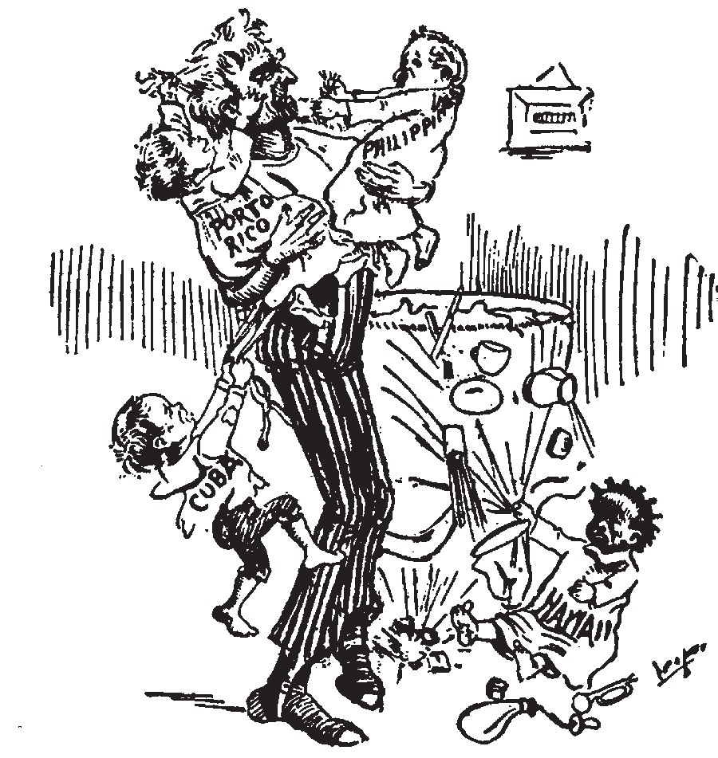
demonstrations against measures the U.S. government took to limit self-rule.
News, Detroit

We hold that the policy known as imperialism is hostile to liberty and tends toward militarism.... We insist that the subjugation of any people is ‘criminal aggression’ and open
“
disloyalty to the distinctive principles of our government.”
—Platform of the Anti-Imperialist
League, 1898

The United States established a protec- torate over Panama in 1903 to pave the way for building the Panama Canal, and acquired several small Pacific island groups after World War I. Nonetheless, there was little public support in the United States for imperial ex- pansion. In the Philippines, American officials turned over much of the responsibility for governing the islands to Filipinos. In 1946, the Philippines gained full independence.
In the Caribbean as well, the United States wanted to avoid the administrative costs and military commitment associated with con- trolling an empire. Rather, the chief goal of
U.S. policy in the region was to safeguard American business and security interests. U.S.

leaders retained the right to oversee Cuba’s economic policies and foreign relations until 1934.

World War I: Making the World Safe for Democracy
When war broke out in Europe in August 1914, the overwhelming majority of Ameri- cans felt that the United States should stay out of the fighting. President Woodrow Wilson, who mistrusted the great powers of Europe, shared this view. He established a policy of strict neutrality to avoid U.S. involvement in the war. Wilson believed that the United States should occupy a special place in the world as a beacon of democracy, freedom, and justice.
In 1914, this belief lay at the foundation of his policy on neutrality. By April 1917, however, Wilson evoked the same ideals when he called on Congress to declare war against Germany.

How did the Allied victory open new opportunities in international relations?
Like the Spanish-American War, World War I was a military success for the United States. Fresh American troops helped tip the balance in Europe against Germany, leading to an Allied victory in 1918. America’s vital role in the defeat of Germany brought with it new questions about the nation’s role in the post- war world.
Wilson’s peace proposal, known as the Fourteen Points, called for international cooperation to maintain world peace. Wil- son envisioned an association of nations that would protect the political independence and territorial integrity of both large and small states. He imagined that the United States would join this proposed League of Nations and play a prominent part in safeguarding the
peace of the new international order. A nation- al debate about whether to join ensued with President Wilson at its center. Wilson found that he had underestimated the concerns that Americans had about his ideas for internation- al cooperation.

For the first time in history the counsels of mankind are to be drawn together and concerted for the purpose of defending the rights and improving the conditions of working people—men, women, and children— all over the world. Such a thing as that was never dreamed of before, and what you are asked to discuss
in discussing the League of Nations is the matter of seeing that this thing is not interfered with. There is no
“
other way to do it than by a universal League of Nations....”
—Woodrow Wilson, September 1919

Why did the Senate oppose Wilson’s proposals?
The national debate began with consid- eration of the League of Nations in the U.S. Senate. At the heart of the debate was the proposed structure of the league. Republican senators, the leading opponents of Wilson’s proposals, argued that the treaty would require League members to come to the defense of any member under attack. They were concerned that the United States might be compelled
to fight to preserve the borders of a French colony in Africa or protect British imperial interests in India.

I am anxious as any human being can be to have the United States render every possible service to the civilization and the peace of mankind, but I am certain we can do it best by not putting ourselves in leading strings or subjecting our
“
policies and our sovereignty to other nations.”
—Senator Henry Cabot Lodge, August 1919

Rather than negotiate with his opponents in the Senate, Wilson decided to take his case to the American people, hoping to rally public opinion behind his vision for U.S. foreign policy. In September 1919, he traveled eight thousand miles by rail, giving forty speeches in twenty-nine cities during the course of

“We Told You It Wouldn’t Work!”

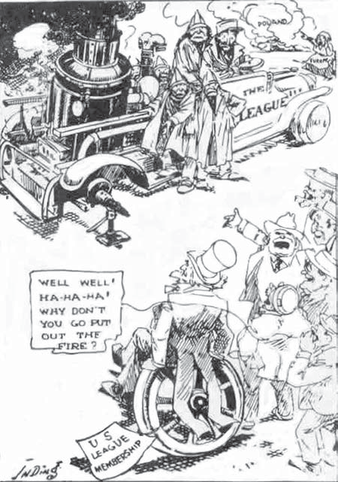

a three-week speaking tour. Wilson’s pleas were communicated nationally through the twenty-one journalists who traveled with him on the train and ran daily stories on the trip. The pace of the trip coupled with preexist- ing medical problems proved to be too much for Wilson physically. On September 25, Wilson gave his last speech before collapsing from physical exhaustion. Upon his return to Washington, a crippling stroke silenced Wil- son’s voice. Partially paralyzed, the president in 1920 watched as the Senate rejected U.S.
Jay N. Darling. The Des Moines Register, c. 1920.
membership in the League of Nations by a vote of 38-53, far short of the two-thirds majority needed to approve the treaty. One of the trea- ty’s foes, Republican Warren G. Harding, went on to win the 1920 presidential election by pledging to return the country to “normalcy.”

What were American attitudes toward foreign affairs in the 1920s and 1930s?
As the prosperity of the 1920s gave way to the depression of the 1930s, many Americans
sought to shield their country from the turmoil in Europe. The establishment of communism in the Soviet Union and the emergence of fas- cism in Europe added to Americans’ desire to insulate themselves.
The League of Nations proved weak and ineffective without U.S. involvement. In the 1930s, the League failed to stop Japanese, Italian, and German aggression. The overseas conflicts from which Americans hoped to isolate themselves were becoming a mounting threat to world peace.
When fighting broke out in Europe in September 1939, most Americans sympathized with Britain and France in their struggle against Nazi Germany, but viewed the war
as a European matter. Japan’s attack on Pearl Harbor on December 7, 1941 instantly changed their attitudes. The United States entered World War II with firm resolve and mobilized its vast resources. By 1945, the Allies were victorious in Europe and the Pacific.

Post-World War II: Confronting the Soviet Challenge
When World War II ended in 1945, the United States stood unrivaled as the strongest nation on earth. Unlike the combatants of Eu- rope and Asia, the United States escaped the devastation of war. U.S. industry reached new levels of productivity during the war years, supplying much of the equipment for the Allied victory. Moreover, in 1945 the United States was the only country to possess atomic weapons.
For many Americans, peace represented an opportunity to withdraw again from the center stage of world affairs. With Japan’s surrender in August 1945, President Harry S. Truman moved quickly to bring U.S. troops home and to allow the country’s twelve mil- lion soldiers to return to civilian life. By 1947, the government had cut the military to 1.4 million personnel.
But even as Americans were enjoying the benefits of peace, many U.S. policymakers rec- ognized that World War II had fundamentally changed the international order. Britain, after

“But what part shall the meek inherit?”

From Stettin in the Baltic to Trieste in
the Adriatic an iron curtain has descended across the Continent. Behind that line lie all the capitals of
“
the ancient states of Central and Eastern Europe. Warsaw, Berlin, Prague, Vienna, Budapest, Belgrade, Bucharest and Sofia, all these famous cities and the populations around them lie in what I must call the Soviet sphere, and all are subject in one form or another, not only to Soviet influence but to a very high and, in some cases,
increasing measure of control from Moscow.”
—Winston Churchill,
1946

Soviet leader Stalin walks off with the world.
Charles G. Werner in The Indianapolis Star, 1949.

dominating much of the globe for two centu- ries, was no longer able to maintain its vast empire. Likewise, the other leading European powers—France, Germany, and Italy— were in no position to assert themselves internation- ally. Most importantly, the war strengthened the hand of the Soviet Union.
In defeating Nazi Germany, Soviet forces had swept over Eastern Europe. They re- mained in place and provided the muscle behind Moscow’s political control of the region. At the same time, the Soviets sought to extend their influence to Iran, Turkey, and
Greece. In 1946, Winston Churchill, the British prime minister during the war, said that the Soviets had cut off Eastern Europe from its western neighbors by drawing an “iron cur- tain” across the continent.

What role did the United States take on in post-war Europe?
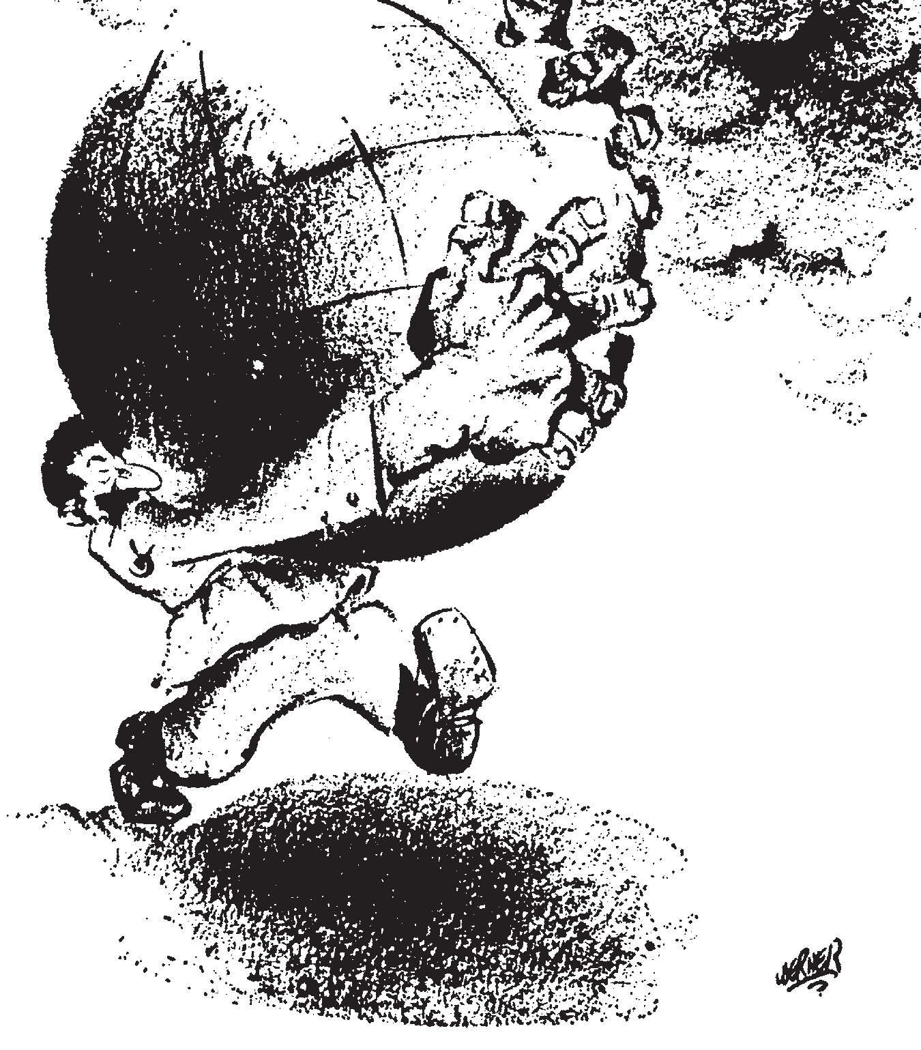
Discussion about how the United States fit into the new in- ternational order gained the attention of the American public in 1947 and 1948. In March
1947, President Truman unveiled an extensive aid package for Greece and Turkey. In what came to be known as the Truman Doctrine, he pledged U.S. support for governments every- where fighting against communist uprisings.
At the same time, U.S. strategists were designing a far-reaching economic assistance effort to rebuild Europe. Known as the Mar- shall Plan, the foreign aid program called for the United States to spend billions of dollars on reconstruction in Europe. The Marshall Plan was based on the belief that the United States should try to contain the expansion of

Soviet communism and that the best way to do so would be the rehabilitation of the economic structure of Europe.

...It has become obvious during recent months that this visible destruction was probably less serious than the dislocation of the entire fabric of European economy.... It is logical that the United States should do whatever it is able to do to assist in the return of normal economic health in the world, without which there can be
“
no political stability and no assured peace.”
—Sec. of State George Marshall, June 1947

Many leading policymakers in the ad- ministration of President Truman had come to view conflict with the Soviet Union as inevitable. They argued that the United States should stand firm against Soviet ambition.
Reconstruction in Europe, they argued, would be a significant part of this effort. Truman was particularly concerned that the Soviets would promote the spread of communism in the
war-ravaged countries of western and southern Europe.
Congress considered the Marshall Plan for ten months. At the same time, hundreds of
town hall meetings convened across the coun- try to weigh the future of U.S. foreign policy. Truman’s approach encountered opposition from a variety of perspectives. Traditional conservatives feared that making new com- mitments abroad would inflate the budget and give the military too much power. Meanwhile, many liberals believed that the Marshall Plan would divide Europe into two hostile camps and would undermine the cooperative mission of the newly formed United Nations (UN).

How did the United States respond to the Soviet threat?
Criticism of Truman’s policies was under- cut by events. In 1948, the Soviets sponsored a coup to topple the government in Czechoslo- vakia and imposed a blockade of West Berlin
to force the Allies out of the city. Although Americans were wary of becoming entangled in international affairs, they also remembered how Nazi Germany expanded its power in the 1930s through threats and intimidation while the United States watched from the sidelines. Many Americans felt that the experience of the 1930s justified a determined stance against Soviet communism.

It is clear that the main element of any United States policy toward the Soviet Union must be that of a long- term, patient but firm and vigilant containment of Russian expansive tendencies.”
“
—U.S. Diplomat George Kennan, July 1947

By the end of the 1940s, the United States had set a course for an active role in interna- tional affairs. The declaration of the Truman Doctrine and the passage of the Marshall Plan in 1948 signaled that the United States was willing to make a long-term investment in the future of Europe. Equally important was the creation of the North Atlantic Treaty Organi- zation (NATO) in 1949. Under the provisions of NATO, the United States, Canada, and ten countries of Western Europe pledged to come to one another’s defense if any member were attacked.

Why did the containment of Soviet expansion in Europe deepen into a global contest?
At the time, most supporters of Truman’s policies imagined that the division of Europe into U.S. and Soviet spheres would last no more than ten or fifteen years. Instead, the Cold War between Washington and Moscow deepened in the 1950s, extended to virtually every area of the globe, and endured for nearly half a century.
In September 1949, the Soviets exploded their first atomic bomb. The next month, com- munists led by Mao Zedong won control of mainland China and joined Moscow in press- ing for the spread of communism worldwide. In June 1950, communist North Korean forces

invaded South Korea, drawing the United States and the UN into a three-year conflict that ended in a stalemate. By the mid-1950s,
U.S. leaders had reluctantly accepted the Sovi- et sphere of influence behind the Iron Curtain.
Moscow’s development of nuclear weap- ons forced American defense planners to devise a new national security strategy to counter the Soviet threat. Presidents Truman and Eisenhower bolstered the U.S. presence in Western Europe to deter Soviet aggression. The United States increased its conventional,
or non-nuclear, forces. American policymakers also hoped to maintain their head start in the arms race. In 1947, Truman ordered that four hundred nuclear weapons be ready by 1953.
Under Eisenhower, the doctrine of “massive retaliation” committed the United States to use nuclear weapons to counter a Soviet attack on Western Europe. The purpose of the policy was to deter an attack from ever taking place. This policy of deterrence would form the cornerstone of U.S. security policy for nearly fifty years.

n Part I, you have read about three critical turning points in America’s relationship to the world in the last century. The
I
challenge for Americans today is to define the role that the nation will have in the twenty-first century. As you read the next two sections on changes in the global environment and U.S. security, think about the turning points of the past. How were ordinary Americans involved in the foreign policy decisions of the last century, and how might Americans be involved today? Will the same factors involved in the twentieth century influence the decisions of the twenty-first? Have our values changed? As you read the following sections, use your knowledge of previous turning points to evaluate the choices available for us today.

Part II: A Changing World

he end of the Cold War left many experts arguing about what the future would be
T
like. Confrontation with the Soviet Union would be replaced by something—but what? Some hoped for a “new world order” of coop- eration to solve the world’s problems. Others wondered if ideological conflict had ended and if all the world would adopt the Western ideas of democracy and the free market. Still others speculated that the principal disagree- ments in international politics would be a “clash of civilizations” between Western cultures and others with different values and beliefs. What has become clear to many is that the world is changing quickly through a pro- cess called globalization.

What is globalization?
Globalization is an umbrella term which refers to the economic, political, cultural, and social transformations occurring throughout the world. It reflects the increased interdepen- dence of various countries and people today. The migration of large numbers of people, as political and economic refugees or as volun- tary immigrants seeking new lives, helps to spread ideas and establish connections among cultures that did not exist before. Ours is not the first era to experience globalization; many periods in history have seen globalization of varying forms. However, globalization today distinguishes itself by its speed and magni- tude. Though the seeds of transformation were sown long before, the end of World War II marked the beginning of a new global era. The wave of globalization since 1945 has funda- mentally changed the face of the international system and has dramatically altered the lives of people around the world.

What has been the role of the United States in globalization?
What may be most striking about global- ization today is that the process is so strongly influenced by one country—the United States. While some praise globalization with an
American face, others are concerned that American dominance will conflict with other societies.
In the past half-century, countries have faced the challenge of navigating through a rapidly changing world. Today, the United States is challenged to reflect upon its leader- ship role in the process of globalization—past, present, and future. The principles of de- mocracy and the free market promoted by
the United States have never been so widely accepted.
Yet, the dominance of the United States has another side. America’s combination of economic, military, and technological strength has put our nation far ahead of potential rivals. As the most powerful nation in the world, the United States is also the most visible nation in the world. American dominance comes from more than just military might. The ability of
  - companies and ideas to expand through- out the world has kindled resentment against the “Americanization” of cultures of different nations.

On top of it all, globalization has a distinctly American face: It wears Mickey Mouse ears, it eats Big Macs, it drinks Coke or Pepsi and it does its computing on an IBM or Apple laptop, using Windows ... and a network link from Cisco Systems.
“
Therefore, while the distinction between what is globalization and what is Americanization may be clear to most Americans, it is not to many others around the world. In most societies people cannot distinguish anymore between
American power, American exports, American cultural exports and plain vanilla globalization. They are now all wrapped into one.”
—author Thomas L. Freidman, 1999

Some fear that the cultures and traditions of their countries will be overwhelmed by the values, popular culture, technologies, and lifestyles of the United States. Some regard
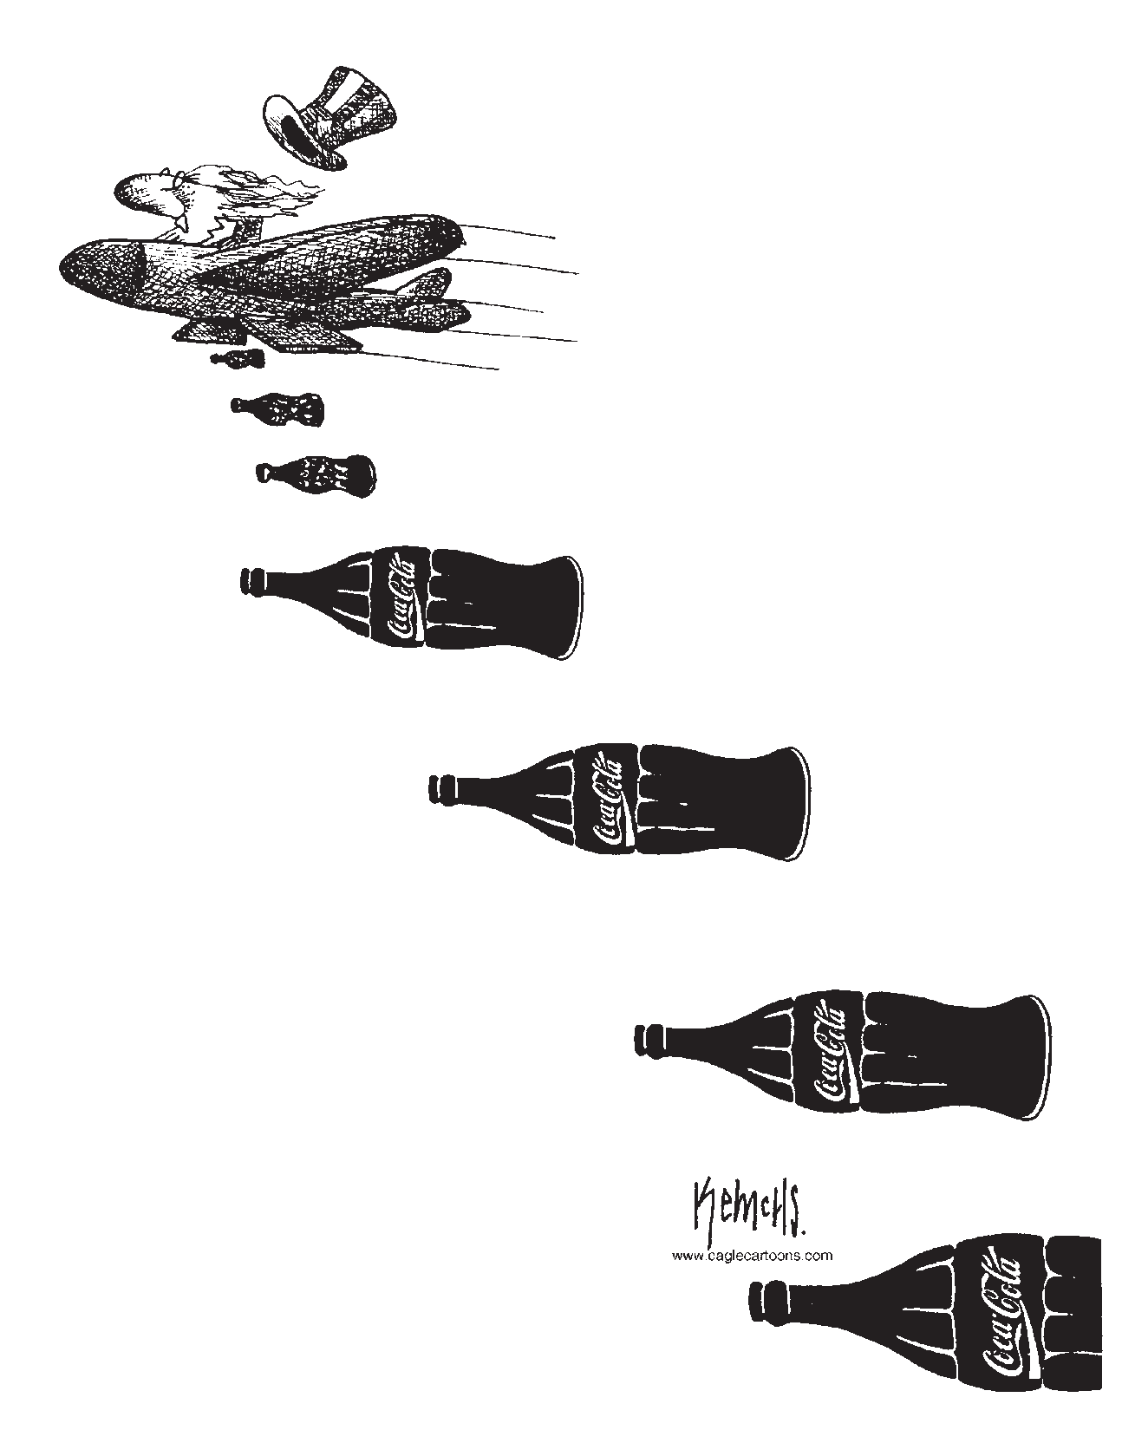
the values conveyed by MTV or Hollywood as harmful—an assault by an immoral American society on traditional values. For many people around the world the rapidly changing global and political environment has led to shifting and uncertain cultural and economic land- scapes.
The four sections which follow— economy,
health and environment, international re- lations, and culture and values—provide
a structure for looking at some current trends and how they play out in the world today. Each section also looks at the U.S. role
in these areas, and challenges you to consider how the United States should act in the future.

Economy
With globalization, the world economy has grown increasingly interdependent. The pro- duction of goods now takes place on a global scale. For example, a good that used to be produced by a single firm within one country may now be produced by people from many firms located all around the world. Additional- ly, an expanding international commitment to free trade among countries has international- ized the market for goods; people have access
helped by the newly emerging economic order because they have the resources to expand production worldwide and to create goods that are in demand internationally. Individuals and small businesses have access to much larger markets and to buyers they did not have access to before. On the other hand, some countries and individuals have been hurt because they are not able to compete with the strongest pro- ducers internationally.
Today, the U.S. economy is the world’s largest. The U.S. dollar serves as the most accepted currency of international trade. The United States is one of the world’s leading exporters and maintains a lead in many of the future’s most promising industries, including biotechnology, space technology, and comput- er software. U.S. corporations have sought a competitive edge by taking advantage of cheap labor in Latin America and Asia. Meanwhile, Japanese and Western European companies have invested in the United States, hoping to tap into American markets.

How have U.S. leaders attempted to stimulate economic growth?
U.S. leaders have attempted to stimulate economic
growth by actively promoting new trade ties. Some of their most no-
table achievements have been the World Trade Organization (WTO) and the North Ameri-

to goods that were previously out of reach. Finally, in addition to the exchange of goods across borders, traders move billions of dollars
daily with the click of a mouse.
Best of Latin America.
Reprinted with Permission.
can Free Trade
Agreement (NAFTA).
The WTO and

What has been the effect of economic globalization?
Economic globalization has had mixed and unequal effects. Some countries have been
NAFTA are both designed to reduce barriers to international trade. The scope of the WTO is worldwide, with a membership of 151 na- tions, while NAFTA is limited to the United States, Mexico, and Canada. The United States has also established bilateral Free Trade

Agreements with eleven other countries. Negotiations are currently underway for an ad- ditional four bilateral agreements.
Joel Pett, Reprinted with permission.

How has the United States responded to economic globalization?
At the end of the twentieth century, the
U.S. economy was cruising in high gear. The United States was benefitting from having played a central role in building the global economy. The gross domestic product (GDP) was growing at an impressive clip. The stock market soared to record heights. Supporters of free trade contended the opportunities created by the WTO, NAFTA, and other trade break- throughs fueled this expansion. At the same time, critics say that the East Asian economic crisis in the late 1990s and an international economic downturn beginning in 2001 un- settled the lives of millions of Americans
and other people around the world, drawing attention to the insecurities of the new global economy.
Globalization has swept away the employ- ment security of the past. Businesses large and small must learn to compete on a global scale or be left by the wayside. Economists have noted that the United States has been more successful than much of the world in adjusting to these demands. The United States has, for
the most part, turned the forces of change to its advantage.

What do supporters of free trade say?
Supporters of more open trade argue that everyone has the potential to be better off when developing economies join the global marketplace. They contend that countries with free trade systems support the growth of democracy. New industries geared toward ex- ports spring up in developing countries, while consumers benefit from a wider selection
of competitively priced products. Investors benefit from opportunities for higher returns. Likewise, they argue that removing restrictions on financial markets fuels growth in develop- ing economies in the long run.

Free trade is a proven strategy for building global prosperity and adding to the momentum of political freedom. Trade is an engine of economic growth. It uses the power of markets to meet the needs of
“
the poor. In our lifetime, trade has helped lift millions of people, and whole nations, and entire regions, out of poverty and put them on the path to prosperity.”
—President George W. Bush, August 2002

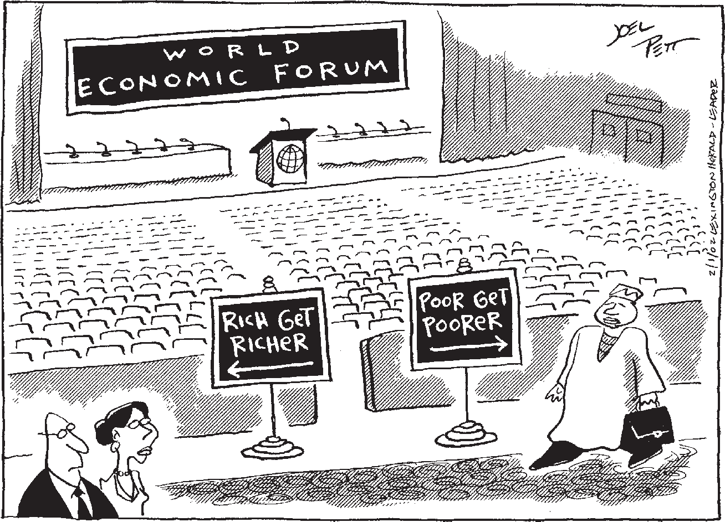
What do critics of free trade say?
Many critics warn that
U.S. policies favor big busi- ness and ignore the interests of workers. Some people want the United States to withdraw from the WTO and other trade organizations in order to protect American jobs. Others argue for re- form of the trade system as a whole.
Critics of free trade maintain that losers outnum- ber winners in the global economy. Among the los-

ers are hundreds of thousands of American workers who have lost manufacturing jobs in recent years and tens of millions of people in the developing world who have lost their jobs or businesses. According to the critics, the winners are mainly rich investors who shift their money from one market to another and big corporations that relocate factories to the developing world to take advantage of low- wage labor. The losers, free-trade opponents assert, are typically found among the working class and the poor.
Positions on Free Trade Policies
Supporters Say: | Critics Say:
People have more access to cheaper products | Income disparity increases in the short run
Businesses have more access  to buyers | Jobs are lost in developed nations
Unrestrictive trade promotes growth and wealth in  the long run | Regional economic downturns quickly become global
Democracy increases as a tag-along  to free trade | Smaller countries or less wealthy individ- uals have less power than wealthy corporations

Ongoing protests at the WTO ministerial meetings highlight the unease generated by the evolving international economic system and capture the attention of world media and the public. A broad coalition of organized labor, environmentalists, human rights activists, and non-governmental organizations continues to protest the free-trade policies favored by the United States and other governments. Many of these protesters also argue that free trade and democracy are not linked, citing the case of China, which is becoming more open in trade policies but not becoming more democratic.
Demonstrations against “globalization without representation” continue whenever the WTO convenes a meeting. These protestors say that
globalization does not represent the interests of ordinary people.

Undoubtedly trade creates winners and losers. A good case can be made that the winners win more often than the losers lose, so the overall effects of trade are positive. But
“
the distributional impacts can’t be ignored. The political reality is that winners don’t compensate losers. The only way those who lose from free trade can hope to be compensated is if they actively oppose it.”
—former Secretary of Labor Robert Reich,
1999

How has free trade affected income levels?
In the short run, inequality between the highest incomes in the most developed countries and the lowest incomes in the
least developed countries continues to grow. Inequality within many countries has also in- creased. In the United States, for example, the gap between the rich and the poor has grown since the 1980s. Per capita income in the Unit- ed States and other wealthy societies is forty times greater than per capita income in the world’s poorest countries. The United States and other highly developed countries continue to dominate international markets, and less developed countries struggle to compete, with varying degrees of success. The UN estimates that 1.5 billion people—about a quarter of the world’s population—get by on $1 or less a day.
While the levels of poverty are declin- ing in some regions, including parts of Latin America, South Asia, and East Asia, poverty continues to rise in other regions, including
much of Sub-Saharan Africa. For many people, questions about the future of international economic policy remain.

Human Health and the Environment
A second set of major issues revolves around human health and the environment. Since the earliest days of international diplo-

macy, states have generally come together to discuss matters of war and trade. The health of the world population or of the world envi- ronment, if considered at all, were thought
of strictly in a local context. Recent years, however, have witnessed a con-
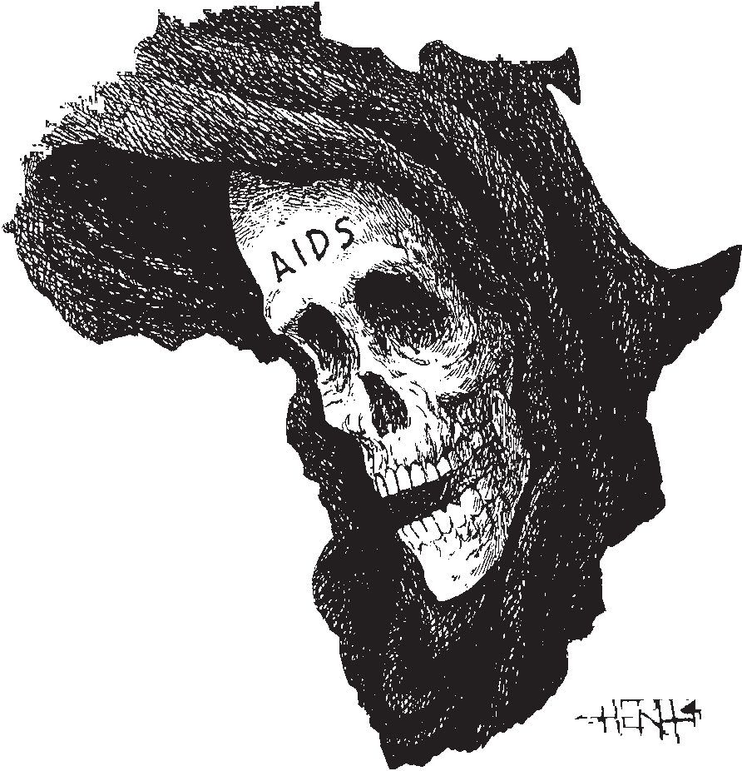
ceptual leap.
Environmental and health-related problems are increasingly seen
as global in scope. A coordinated interna- tional approach has come to be seen as necessary. For example, because greenhouse gases
are dispersed throughout the atmo- sphere, nations of the world recognize that climate change and the resulting environmental destruction need to be addressed in the international arena. Likewise, the spread of AIDS does not follow national borders and the epidemic is now a worldwide health crisis.

What are some current health concerns?
While there are a number of health con- cerns facing the world today, three are both widespread and especially deadly: HIV/AIDS, malaria, and malnutrition.
HIV/AIDS: In 2007, an estimated thirty- three million people were living with HIV/ AIDS. The impact of HIV/AIDS has not been felt equally the world over: incidence of HIV/ AIDS is highly concentrated in the develop- ing world. Sub-Saharan Africa, home to just 11 percent of the world’s population, has 67 percent of the world’s cases of HIV/AIDS. In Botswana, Zimbabwe, and Swaziland, more than a quarter of the adult population is HIV positive or suffering from AIDS.
Poorer nations often lack the resources and infrastructure to educate their citizens about the causes and prevention of HIV/AIDS and to provide treatment for those who are infected. Furthermore, the political instability that plagues parts of the developing world worsens the epidemic. At the same time that conditions
in developing countries intensify the effects of HIV/AIDS, the prevalence of the disease makes further economic development more difficult.
The United States donates more than any other nation to international HIV/AIDS re- search and assistance programs, though critics
say the United States could afford more. Non-Governmental Organiza- tions (NGOs) and foundations also contribute resources in the fight
against HIV/AIDS. As the impact of the HIV/AIDS epidemic grows stronger in the years ahead, the United States will have
to make important choices about its goals and priorities in fighting the disease. Should we concentrate our resources on combating the disease at home?
What should be our priorities in foreign aid—fighting the dis- ease itself, increasing access to medicines, or assisting economic development?
Malaria: Another significant international health concern is malaria. Malaria is the single largest killer in Africa and in many tropical developing countries. Health experts esti- mate that two children die of malaria every minute. Treatment of the infection, transmit- ted by mosquitoes, is straightforward and relatively cheap; however, treatment remains largely unaffordable or inaccessible for many who contract the disease in the develop-
ing world. Environmental factors, such as natural disasters or close quarters in refugee camps, increase a population’s vulnerability to malaria. As of 2008, the United States had contributed $2.5 billion to the Global Fund to Fight HIV/AIDS, Tuberculosis, and Malaria, a leading international group in the fight against malaria.
Malnutrition and Hunger: An additional important international health issue is mal- nutrition and hunger. Malnutrition, like HIV/ AIDS and malaria, is disproportionately prevalent in the developing world. While malnutrition is in some cases a matter of un-

derproduction of food in a region, it is more likely a matter of lack of access to adequate food in poor populations. The UN estimated that in 2008 approximately 854 million people were undernourished. Some experts note that famines never take place in democratic coun- tries with a free press. Without a free press a government can withhold information about small crises which then become larger ones.
Today, the U.S. is the greatest contributor to the World Food Program (WFP), donating nearly half of the annual budget—about $1.1 billion dollars in 2006. While uncertain or limited access to adequate sustenance—called “food insecurity”—is often considered a prob- lem of the developing world, it is a symptom of poverty the world over. In fact, according to the U.S. census, over 11 percent of households in the United States are thought to be “food insecure.” In the years to come, the United States must determine where to focus its ef- forts in addressing malnutrition and hunger.
For example, should we focus our efforts to fight hunger at home or abroad?

What are some of the leading environmental concerns?
Policymakers disagree about the extent of damage to the environment and about the di- rection the environment is heading. Scientists agree that climate change, which is character- ized by an increase in the earth’s temperature called the “greenhouse effect,” has worsened as a result of human activity. Scientists say the problem will continue to harm the environ- ment in the future if we continue to expel the gases into the atmosphere which cause climate change. Those gases, present in small quanti- ties naturally, are increased dramatically when people burn fossil fuels like coal, oil, and natural gas in industrial processes and to heat their homes and drive their cars. Other major environmental problems include the destruc- tion of the ozone layer in the atmosphere, water pollution and acid rain, deforestation, and the decline of biodiversity.

How have international leaders begun to deal with environmental problems?
Several international conferences in recent years have raised the profile of global environ- mental problems. In 1992 the largest gathering of international leaders in history met in Rio de Janeiro, Brazil at what became known as the Earth Summit. The UN protocol, which 150 governments signed in Rio, set in motion a series of conferences among governments on climate change that led to a 1997 conference held in Kyoto, Japan. More recently, more than ten thousand policymakers, environmentalists, and corporations met at the Climate Change Conference in Bali, Indonesia in 2007.

What unresolved conflicts prevent cooperation among nations on environmental issues?
These conferences have offered challenges to policymakers worldwide. It has been dif- ficult, for instance, for countries to agree on how to combat these problems, and especially to decide on who is responsible and should make changes to limit future problems. The economy of a particular country, its values, and its political structure all contribute to its stance on environmental issues.
One political battle pits wealthy, de- veloped nations against poor, developing countries. On the whole, people living in the former group (often called collectively the North) have access to a healthier environment than people living in the latter group (often called the South). Additionally, countries in the North tend to use far more resources. Until recently, Northern countries also contributed far more pollution than Southern ones. That gap is closing as population growth in devel- oping countries has put pressure on countries to develop quickly with less concern for environmental impact. The United States has called for developing countries to curb popula- tion growth and reduce emissions, while it has bristled at proposals which might harm U.S. economic growth.
In many respects, the North-South dispute set the tone for the agreements that emerged from the Earth Summit in Rio and the Kyoto

conference five years later. In the eight hundred pages of guidelines produced at
Number of Democratic States in the World

the Earth Summit, many of the thorniest
issues were avoided. Population growth was hardly mentioned due to pressure from Southern countries. (Population growth was addressed at the 1994 Cairo Conference on Population and Develop- ment, where there was a mandate for education as the best means of curbing
Democracies
14.3 %

Non-democratic states 85.7%
Non-democratic states 37.5%

Democracies 62.5%

population growth.) At the same time, developed nations largely succeeded in protecting corporations that operate in many countries from new regulations.
Data from "Democracy's Century,” Freedom House.

How has the U.S. participated in environmental regulation?
With less than 5 percent of the world’s population, the United States consumes about 23 percent of the world’s energy and produces over 27 percent of the world’s output of goods and services. The United States also supplied much of the early initiative to address global environmental problems. Today, the United States is no longer on the forefront of world- wide environmental regulation. Current U.S. policy reflects the idea that economies need to grow in order for environmental issues to be solved.
Many Northern nations, particularly those in Europe, are more willing to eliminate threats to the environment, even if eliminat-
ing those threats is economically difficult. The United States did not sign the treaty which emerged from the Kyoto conference in part because it felt that the treaty would unfairly burden the U.S. economy.
The role of the United States in future international environmental policy is unclear. Some hope that the United States will take an active role in promoting “green” technologies such as hybrid cars and hydrogen fuel cells, and in reducing greenhouse gas emissions.
Others would like the United States to work more closely within international frameworks and guidelines for environmental protection. Still others prefer that government stay out of the regulating business and let market forces determine the direction U.S. citizens will take.

1950 2000

International Relations
Over the past twenty-five years, democracy has spread along with free-trade capitalism around the world. Many newly emerging countries in Asia, Africa, Latin America,
and the former Soviet bloc have pursued transitions to democracy. Promoting these transitions around the world has been one of the United States’ principal foreign policy
priorities for several reasons. Among them is the belief that democratic countries respect the rights of their citizens and that wars between democratic nations have been virtually non- existent historically.
Whether democracy is universally valued or even universally possible remains unset- tled. President Bush has argued that “liberty is the direction of history” towards which all of the world is working. Others argue that de- mocracy reflects some people’s cultural values rather than universal human values. In a 2006 study conducted by the Pew Charitable Trusts, 30 percent of those surveyed in Indonesia,
26 percent of those in Jordan, and 25 percent of those in Nigeria agreed that Western-style democracy would not work well in their coun- tries.

What is the role of international organizations?
International governmental organiza- tions (IGOs) seek to resolve problems that affect multiple states. These groups set rules for states which choose to be members. The
United Nations (UN), which was formed to ad- dress issues of international security, includes all countries of the world. Other organizations

are regional: the European Union (EU) and the African Union (AU) are examples. IGOs have proven to be a significant forum for dialogue and debate among states. To many, these organizations are a vehicle for a new form of international relations.
Governments around the world have react- ed differently to the emergence of these new organizations. To some states, the authority of international organizations is seen as compet- ing with their own. Some leading figures in the United States, for example, worry that the authority of IGOs threatens U.S. sovereignty, and could override the U.S. Constitution. To others, international organizations are thought to bolster national power by increasing coop- eration and pooling resources. For instance, members of the EU follow the laws passed by a multi-national parliament, have all-but-dis- solved borders between EU countries, and are in the process of adopting a single currency (the euro).

What concerns exist about the organization of international bodies?
Despite concerns on the part of some in the United States about the preservation of state sovereignty, the U.S. plays a leading role in many international organizations such as the World Bank and the International Mone- tary Fund (IMF). The World Bank and the IMF work to address issues of international eco- nomic development and global finance. The United States contributes the most money, and as a result is the single strongest governmen- tal voice in these organizations. Many critics argue that these organizations serve more as proxies for U.S. foreign policy than as inde-
pendent organizations.
In fact, some countries’ voices are more heard than others. Permanent members of the UN Security Council (China, France, Russia, Great Britain, and the United States), for in- stance, have much more sway in international politics than others. Given this discrepancy, many have begun to consider the importance of democratization not only within states but in the international governmental organiza- tions to which states belong. Some have called for a reform of the UN so that less powerful na- tions can participate at the same level as more powerful ones. Others say that the Security Council structure should be changed to reflect the changes in the political order since the founding of the UN after World War II.
Definitions
A “State” is a country with a govern- ment that is recognized by its citizens and other countries and has sole control over its military power.
“State sovereignty” is the right of a country to make its own decisions free from outside interference.

What other groups have challenged the role of states in world politics?
In addition to the large international gov- ernmental organizations, groups smaller than states have begun to play a significant role
in world politics as well. For example, non- governmental organizations (NGOs) have had a significant impact around the globe. NGOs are generally non-profit, private organizations with a particular interest in a public policy issue. NGOs not only lobby governments to achieve their goals, but more and more they fulfill the role of governments by pursuing their goals in the field. Different NGOs work around the world pushing for reform in issues of education, human rights, environmental policy, health care, and poverty alleviation.
Data from Union of International Associations.
Year | Number of NGOs
1909 | 176
1978 | 9,521
1989 | 20,063
1999 | 43,958

Often, NGOs are more successful at solving problems and delivering services than govern- ments because they have financial backing from donors and can sometimes act outside of government restrictions. In some cases NGOs have taken on roles that U.S. and other govern- mental agencies used to maintain.
Tragically, other small groups have also gained international importance. Terrorists and criminal organizations are both examples of this trend. They also work around the world to promote their “ideals.” Terrorist groups are sometimes funded by the dictatorial regimes of particular countries, but their members are widespread. You will read more about the role played by terrorist organizations in Part III.
What role these new international and non-governmental organizations will have in the years to come remains to be seen, and
what effect they will have on U.S. policy and interests remains an open question.

Culture and Values
Different cultures and nations, like in- dividuals, often have different values. The process of globalization has challenged and sometimes changed values within many societies around the world. In one sense, glo- balization has produced strong pressures for harmonization of values around the world—in particular, a value in universal human rights. In another important sense, globalization has resulted in the emergence, interaction, and competition of many different value systems on the global stage. While there have always been debate and discussion within cultures about values, globalization has brought these debates to a global scale. Sometimes the in- teraction of differing value systems has been
a source of positive change and growth. At times, such interaction has also been a source of great tension.
The globalization of culture and values has brought Western conceptions of democ- racy and liberty to many areas of the world in the last twenty-five years. In many cases, the internet and popular culture have helped to spread those ideas. At the same time, however,

Major Elements of the Universal Declaration of Human Rights
Everyone is entitled to:
•life
•liberty
•security
•a nationality
•freedom from slavery, discrimina- tion, or torture
•equal protection under the law
•presumption of innocence until proven guilty
•freedom from arbitrary interference with privacy
•freedom of movement
•freedom to marry and start a family
•ownership of property
•freedom of thought, opinion, expres- sion, association, and religion
•suffrage (the right to vote)
•social security
•work and membership in trade unions
•equal pay for equal work and just remuneration
•rest and periodic holidays with pay
•an adequate standard of living
•free fundamental education

forces such as religious extremism have also increased. Many people resent the “American- ization” of the world and feel that the forces of globalization threaten their culture. For example, eight in ten Africans feel that their
daily customs are jeopardized by globalization. These changes have the potential both to dis- place some cultures and to create new cultural combinations.

How have human rights been incorporated into the values of many nations?
The notion of universal human rights emerged after World War II and the Holocaust. Proponents of these rights argue that there are certain fundamental and absolute rights that every human being possesses, regardless of national laws or cultural traditions. Some of the fundamental human rights, as expressed in the 1948 Universal Declaration of Human Rights, include the right to life, liberty, securi- ty, sufficient standard of living, equality under the law, education, freedom of movement, and freedom of thought and religion. The doctrine of universal human rights emerged in step with pressures for liberty, equality, and de- mocracy.
The international community has enacted economic sanctions and taken military action to punish or prevent extreme abuses of human rights. International courts have held leaders who abused the rights of citizens in their own countries accountable. Particularly in the past fifteen years, the international community has
begun to take a stand against human rights abuses.
On the other hand, how far these human rights will be extended in the twenty-first cen- tury is unclear. Some have raised questions as to how universal these values really are. Some argue that since the tenets of individual liberty and equality are Western values, they do not encompass all of the world’s value systems, especially those with strong communal tradi- tions.
The human rights values championed by the UN and others are also criticized on political grounds. China, Russia, and other non-Western powers, as well as conserva- tive critics in the United States, contend that an emphasis on human rights will topple a
crucial pillar of the international system—the principle of state sovereignty. Defenders of state sovereignty maintain that states should be free from external control. Those who wish to prioritize human rights argue that state sov- ereignty should be limited when states harm their citizens.

ou have read in this section about some of the numerous challenges facing the United States and the world. You have
Y
begun to examine the complex and interrelated issues that U.S. leaders are facing right now in this era of change and globalization. As you read the next section on security, try to keep in mind some of the issues raised above and where they might intersect with security. U.S. policies about these issues inform our policies on security issues, and our actions in areas such as economics and the environment impact our security in the world. For example, how do the issues surrounding culture and values affect our policy in the Middle East? How do our free trade policies affect our relationships with impoverished nations? How do our donations to global disease- fighting organizations affect security issues in the developing world?

Part III: Security in the Twenty-First Century

hroughout history, states have taken threats to their security with the utmost
T
seriousness. Today many Americans worry about the threat of terrorism, but their parents might be able to tell them about the threat of nuclear war during the Cuban missile crisis. Their grandparents could recount the trying times of the Second World War. As you read in Part I, Americans have often faced difficult questions about how best to secure the future of the United States. Because lives are often at stake, the debates about these issues are
sometimes contentious and involve competing values and beliefs. Nevertheless, throughout American history these debates have been cen- tral to an active and healthy democracy.
In this section of the reading you will re- view some of the changes in the international system since the end of the Cold War. You will explore developments in international secu- rity of the twentieth century in order to better assess the situation at the dawn of the twenty- first century. You will also examine how U.S. policy has contributed to the international debate about the use of force, particularly surrounding the issue of “preventive war.” Finally, you will examine three important security problems for the twenty-first century: the war in Iraq, terrorism, and nuclear weap- ons.

After the Cold War
With the end of the Cold War came the opportunity for the UN to increase its role in the sphere of international peace and secu-
rity. Although the organization was still torn by rivalries among the world’s most powerful nations, the ideological gridlock of the Cold War no longer blocked decision-making. For the next ten years the United States and other nations wrestled with defining security issues and how best to deal with them. Each situa- tion during that time tested the international system, set new precedents, and shaped the response to the next event.

How did Iraq challenge the international community in 1990?
In August 1990, one hundred thousand troops from Saddam Hussein’s Iraq poured across the desert border and occupied Kuwait. A few years earlier, during the Cold War, the United States might have hesitated to take strong action against Iraq for fear of setting
off a wider international crisis. By mid-1990, however, both the world and the U.S. outlook had changed. President George H. W. Bush spoke of erecting a “new world order” in which the leading powers would work togeth- er to prevent aggression and enforce the rule of law internationally.
The first President Bush carefully built do- mestic and international support for measures against Iraq. First he pushed for an economic blockade against Iraq. In November 1990, Bush won UN approval to use “all necessary means” to force Iraq out of Kuwait. A deadline was set—January 15, 1991—for Iraq to withdraw from Kuwait.
As the deadline approached, the United

The UN and Conflict Resolution
Immediately following World War II, the founders of the UN saw their primary task as resolv- ing conflicts between states. They had witnessed the failure of the League of Nations to stop the aggression of Germany and Japan against their neighbors. The UN’s founders recognized the divi- sion between Soviet communism and the free-market democracies of the West (led by the United States, Britain, and France). Nonetheless, they hoped that the permanent members of the Security Council would share a common interest in maintaining global peace. The founders of the UN also understood that the support of every major power was essential to the organization’s success.

States positioned 540,000 troops in Saudi Arabia. America’s European allies, as well as several Arab states, contributed forces.
Despite Saddam Hussein’s prediction of “the mother of all battles,” his army proved no match for the United States and its allies. After fulfilling the UN authorization to drive Iraqi forces from Kuwait, Bush brought the ground war to a halt and allowed the remnants of Iraq’s front-line divisions to limp northward.
When the first war against Iraq ended in 1991, U.S. forces set up a UN operation in northern Iraq to protect the 3.7 million Kurds from Saddam Hussein. Until the second U.S. war on Iraq in 2003, the Kurds depended largely on the international community to pro- tect them from the Iraqi army and to provide them with relief supplies.

How did events in Somalia demonstrate problems with humanitarian intervention?
While the intervention in northern Iraq seemed to provide a new model for humani- tarian intervention, events in Somalia in the early 1990s showed the problems with this kind of involvement. Less than two years after defeating Iraq, the first President Bush sent twenty-five thousand American troops
to Somalia. The U.S. sent these troops at the urging of the UN to safeguard international relief efforts in the war-torn nation. Instead of establishing a successful model for outside in- tervention, the Somalia operation turned many Americans against involvement overseas.
The American public was particularly out- raged by a clash in October 1993 between U.S. forces and a Somali militia that left eighteen Americans and hundreds of Somalis dead.
Television pictures of the body of an Ameri- can soldier being dragged through the streets of Somalia’s capital horrified viewers and led President Clinton to order an American with- drawal from the country. By the time the last American troops left in March 1994, Somalia had slipped into chaos. The UN evacuated the final remnants of the UN force from the coun- try in 1995, leaving behind a nation without an effective central government.

Why was the war against Yugoslavia important?
The war against Yugoslavia in 1999 estab- lished a new precedent. For the first time, a U.S.-led international coalition launched a war to stop a government from carrying out hu- man rights violations and genocide within its own borders. The United States and its NATO
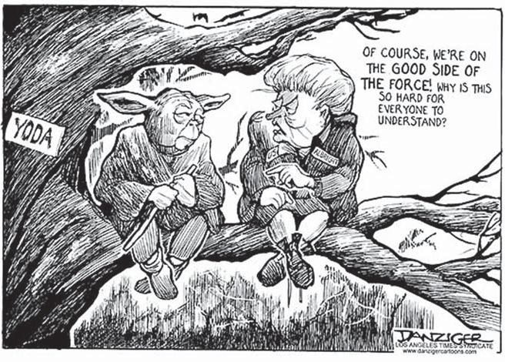
allies intervened militarily to stop the Yugoslav gov- ernment from committing human rights violations and genocide against eth- nic Albanians, the majority population in Kosovo, a region within Serbia.
Because of opposition from China and Russia, this intervention did not have the support of the UN Security Council. Sensitive to inter- national scrutiny of their human rights records, China and Russia maintained that such an intervention would violate the principle of state

This cartoon depicting President Clinton’s secretary of state, Madeleine Albright, shows that doubts about U.S. foreign policy are not new.
Jeff Danziger. Reprinted with permission.
sovereignty as protected in the UN Charter. Chinese and

Russian leaders also argued that this concern for human rights was simply a ploy to bol- ster the influence of the United States and its NATO allies. Their staunch opposition to the intervention in Yugoslavia exposed a disagree- ment over what principles should govern international relations.

A New National Security Strategy
Following the terrorist attacks of Sep- tember 11, 2001, many Americans began to reexamine the U.S. relationship with the rest of the world. The Bush administration has outlined how the government will combat terrorism, work with allies to increase peace, reduce regional conflicts, and encourage de-
mocracy and freedom throughout the world. The Bush administration’s approach to these problems can be found in a document called the National Security Strategy. Many of the ideas are familiar to students of American history. Presidents from Jefferson to Wilson to Reagan to Clinton have argued that the United States has the responsibility to bring democ- racy to other parts of the world. However, some of the key provisions of the strategy have drawn sharp criticism.

What does the National Security Strategy identify as the threats to America’s security?
New Precedents: The Signifi- cance of Three Interventions
In these three cases—the 1991 Iraq War, the intervention in Somalia, and the war against Yugoslavia—various ap- proaches to international conflict were tested. Both the form of intervention and the reasons for it evolved from one situa- tion to the next.
The Gulf War (1991): The UN au- thorized the use of force against Iraq to liberate Kuwait. U.S. forces in northern Iraq stayed to protect Iraqi Kurds from Saddam Hussein. Hope for greater interna- tional cooperation about security grew.
Somalia (1993-1995): UN efforts to use military force to protect relief efforts ended in failure. U.S. enthusiasm for in- volvement overseas decreased, especially when Americans perceived that their security and economic interests were not at stake.
Yugoslavia (1999): A U.S.-led NATO coalition attacked Yugoslavia in 1999 to protect an ethnic minority within Yugo- slavia from genocide. The United States bypassed the UN when it failed to win approval to use force.
The Bush administration believes that international relations have changed since September 11 and that these new threats to Americans demand a military response.
No longer is the world divided between the ideologies of capitalism and communism as it was in the Cold War. The Bush administration believes that it is tyrannical governments and terrorists that pose the most serious threats to American security. The struggle America faces is how to respond to terrorism and the prolif- eration of weapons of mass destruction in the hands of tyrants and rogue states.

We will defend the peace against the threats from terrorists and tyrants. We will preserve the peace by building relations among the great powers. And we will extend the peace by encouraging free and open societies on every continent.”
“
—President George W. Bush, June 2002

What is new in President Bush’s security strategy?
The National Security Strategy maintains that the Cold War policies of deterrence and containment can no longer serve as the only cornerstones of American security policy. The strategy states publicly that the United States will act alone—unilaterally—when necessary. The new strategy also endorses preventive mil- itary action to address potential threats even before an attack against Americans or Ameri- can infrastructure is imminent. Observers call

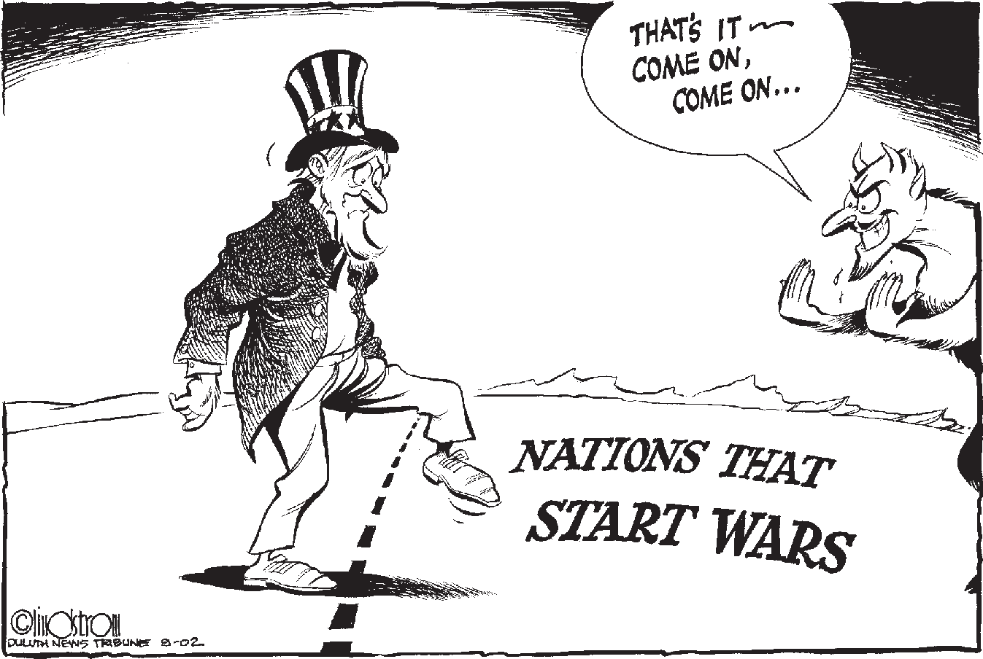

this aspect of the new strategy prevention or preventive war. Observers note that in the past, the United States had reserved the right to act when security threats were immediate. This is referred to as preemption. For example, the Kennedy Administration considered a preemptive attack on Cuba during the Cuban missile crisis. What is different in the current strategy is a lower threshold for what consti- tutes a grave danger worthy of military action. Now possible threats are considered as danger- ous as definite ones.
Stephen Lindstrom, Duluth News Tribune. Reprinted with permission.

Deterrence—the promise of massive retaliation against nations—means nothing against shadowy terrorist networks with no nation or citizens to defend. Containment is not possible when unbalanced dictators with weapons of mass destruction can deliver those weapons on missiles
“
or secretly provide them to terrorist allies.”
—President George W. Bush, June 2002

What do supporters of the strategy say?
Supporters argue that the strategy is a nec- essary response to threats posed by terrorism and tyrannical dictatorships. They say that the more flexible response allowed by prevention and the right to act unilaterally are necessary against terrorists and dangerous regimes. Sup- porters assert that the consequences of failing to act could result in another September 11 or worse. They say the strategy does a good job of defining a vision for a U.S. foreign policy that responds to the challenges of the twenty-first century.
Supporters also note that the National Security Strategy addresses diplomatic and development goals to prevent terrorism from taking root. These goals highlight the connec- tion between security and the issues covered in Part II. They include promoting free markets and free trade around the world; improving the global environment; and offering aid to democratic nations to relieve poverty, increase education, and decrease the spread of HIV/ AIDS and other diseases. The Bush admin-

Another Look at Preventive War
The arguments about the national security strategy are complicated and heated. They are often colored by strong political opinions. The fictional dialogue below illustrates some of the differences of opinion and some of the issues behind the controversy about preventive war.
The setting: A typical diner somewhere in the United States. It is snowing outside, coffee is already poured.
Betsy: Why is this idea of preventive war controversial? It seems like just common sense to me. Why should Americans wait to be attacked before they can defend themselves? I mean if someone had nuclear weapons or something like that it could be a disaster.
Sam: Of course we have a right to self-defense. We should defend ourselves, but America sets an important example for the rest of the world. This preventive war stuff sets a new standard.
The UN recognizes a state’s right to defend itself if an armed attack occurs. Do we want other countries attacking each other based on this new philosophy? Seems like there could be lots of wars for questionable reasons. I mean do we want North Korea attacking Japan and saying they were just preventing an attack by Japan?
Betsy: I see what you are saying. But the rules the UN came up with were made to deal with the problems of the world nearly sixty years ago. Who knew then that terrorist attacks could kill thousands of people? No one knew then of the danger of weapons of mass destruction. The times have changed; it’s time for the rules to change.
Sam: Yes, the times have changed. But you know, international law even allows for states to attack another state for reasons of self-defense if the need is immediately necessary, if they have no other alternative, and if there is no time to consider other options.
Betsy: International law didn’t stop the terrorists on September 11 and it won’t now.
Sam: Yes, I agree. But international law does govern the behavior of states. And states can cooperate to stop the terrorists. Establishing this new precedent may come back to haunt us. Can I use an example? Take that waitress over there: she comes over here and she launches a pre- ventive attack on you and breaks both your arms. Her reason? She argues that you are about to do serious harm to everyone in the diner. Is that fair? By my standard it’s not—she has time to consider other options, call the police for example, consult with others and decide if there are alternatives. Not to mention that there is no evidence of your bad intentions.
Betsy: Unfair example. I don’t know about that waitress, but the United States wouldn’t undertake a preventive war without good evidence. That’s what intelligence agencies are for. Besides, maybe she thinks the police won’t arrive in time or they’re unreliable—you know, like the UN.
Sam: Sometimes intelligence agencies can be wrong.
Betsy: Yes, that’s true, but let’s take another example. Pearl Harbor. Are you saying that if our intelligence agencies had known about the planned attack that using military force would have been wrong?
Sam: Unfair example. We know today that Japan did intend to attack Pearl Harbor in 1941.
My argument is that preventive war is bad when we are not sure of the intentions of an adversary. In the case of Pearl Harbor, acting against Japan would have been justified if we had known then that there was no other way to stop the attack. If we had known of their intentions, it might have been possible to use diplomacy to say, “We know you intend to attack Pearl Harbor. If you do, it will mean war.” Once the Japanese fleet began to approach Hawaii, using military force for self- defense seems justified to me.
Betsy: You put too much faith in law to protect us. There is no longer any margin for error.
Sam: Yes, I agree there is danger. But how do we balance that with the possibility that we might be wrong?
www.choices.edu ■ watson institute for international studies, Brown university ■ choices for the 21st century education Program ■

istration notes that economically depressed nations where many live in poverty are much more likely to suffer from infiltration of terror- ists. The strategy calls on the United States to work with allies to dismantle terror networks and support efforts to achieve freedom and democracy in nations across the world.

What do the critics say?
The National Security Strategy has caused controversy in the United States and abroad. Critics claim that acting unilaterally under- mines any hope for an effective system of collective security and raises legal questions about any action the U.S. does take. They believe that unilateral action also contributes to a negative perception of the United States as an unrestrained superpower—a bully on the world stage—and note that the United States should not be a nation that starts wars.
Concerns have also surfaced about pre- ventive military action. Critics note that intervening militarily before a clearly immi- nent attack is identified violates the principles of international law, which say that states may use force only in self-defense against such an attack.
Critics also worry about an erosion of the shared principles that restrain states from violating accepted international standards.
They suggest that the threat of preventive war might actually lead some countries to rush to develop nuclear weapons as a deterrent to U.S. military action. They argue further that con- tainment, rather than direct military action, can still be effective against security threats from states.
Other critics argue that a U.S. policy of preventive war will lead other states to claim the right to use the same strategy, potentially against U.S. interests. They believe that this will diminish the role of diplomacy and other measures short of war in resolving internation- al security problems.
Critics are also concerned that the strategy has strained diplomatic relations. These critics believe that the negative international reaction
to the policy has limited the negotiating pos- sibilities available to U.S. diplomats.
Finally, some critics are concerned that the National Security Strategy lays out a broad policy but does not include details. They worry that, despite the language in the docu- ment stating that the United States will try to work with various organizations such as the UN and NATO, the reality will not match the language.

Implementing the Security Strategy
Although there are many security prob- lems in the world today, three loom large for the United States. The current challenge in Iraq and the threat of terrorism remain in the news and are significant in most Americans’ minds. The potential consequences of failing to manage the third challenge, the threat posed by nuclear weapons, are overwhelming to consider.

Iraq
After heated debate in the United States, at the UN, and around the world, in March 2003 the Bush administration launched a war against Iraq. The Bush administration feared that suspected Iraqi weapons of mass destruc- tion (WMD) could threaten the United States or its allies. It cited a 2002 Security Council resolution that had warned that Iraq would face consequences for failing to cooperate with UN weapons inspectors as evidence that ac- tion should be taken. Additionally, Secretary of State Colin Powell argued before the UN Security Council that the United States had evidence of Iraqi links to al Qaeda.
President Bush and British Prime Minister Tony Blair saw forceful “regime change” as the next step. France, Germany, and Russia strong- ly disagreed with the idea of “regime change” and would not give support to the war. Al- though a number of nations supported the U.S. position, the Bush administration did not have enough support in the Security Council to get UN authorization for the use of force.

Debates about preventive war and what priority to give to the role of multilateral cooperation intensified. Many could not agree about the nature or urgency of the problem with Iraq or how the international community should address the problem.
Sun.

Baltimore The
Mike Lane,
Reprinted with permission.

What has happened since the invasion of Iraq?
In the spring of 2003, U.S.-led military forces raced through the Iraqi desert and de- feated Saddam Hussein’s military. During their advance, U.S. officials worried that the Iraqi army would use chemical or biological weap- ons. This did not happen. An intensive search for WMD in Iraq began, but no conclusive evidence of WMD or direct links to al Qaeda has been found.
The U.S. military has found other chal- lenges inside Iraq. There have been ongoing attacks against U.S. soldiers that have become increasingly sophisticated. In addition to Iraqi militias, foreign terrorists and criminal gangs are targeting not only the U.S. military but also Iraqi citizens. Violence among groups
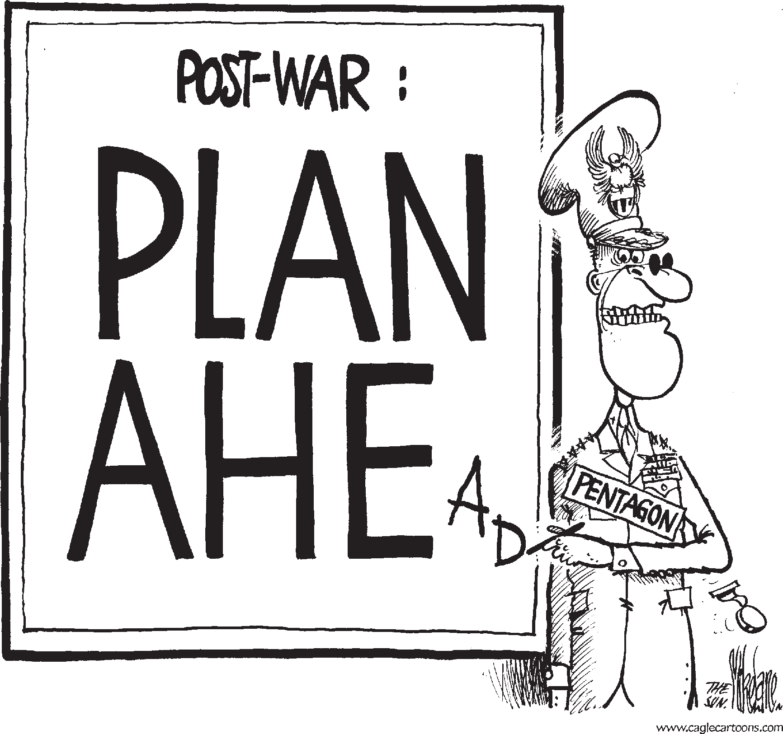
in Iraq has brought Iraq to the brink of civil war. Efforts to restore public order, electricity, water, and other basic services continue.
How long the United States will stay in Iraq is uncertain. Whether the Bush Administration’s goal of establishing a stable, democratic government is even possible is unknown. Many experts predict that achieving it would take years and cost several tril- lion dollars.

Terrorism
Even before September 11, 2001 a government commission led by former Senators Gary Hart and
Warren Rudman warned about the possibility of a terrorist attack against the United States.

Americans will likely die on American soil, possibly in large numbers.”
“
—Hart-Rudman Commission on American Security in the 21st Century, 1999

Since the events of September 2001, at- tention to security threats has dramatically increased. Still, some argue that the country remains seriously under-prepared for another attack. In a follow-up to their 1999 report, Senators Hart and Rudman again sounded alarm bells.

America remains dangerously unprepared to prevent and respond to a catastrophic terrorist attack on
“
U.S. soil. In all likelihood, the next attack will result in even greater casualties and widespread disruption of American lives and the economy.”
—Hart-Rudman Report, October 2002

The Split Over Iraq
Disagreement over the war in Iraq remains one of the most controversial topics in American politics today. While most agree that an end to Saddam Hussein’s brutal dictatorship was posi- tive, many points of contention remain. Below is a brief summary.
Supporters of the Bush policies
“

connect the war in Iraq to the wider war on terror. They contend that it is important that such battles are be- ing fought by the American military on foreign soil rather than through attacks on civilians at home. They state that they are beginning to build
a peaceful and stable Iraq that will be a boon for American security in the Middle East.
Critics argue that the rationale given for the war—an imminent threat from Iraqi weapons of mass destruction and Iraqi connections

...[T]he definition of success...is for there to be a country where the terrorists and Saddamists can no longer threaten the democracy...and where Iraq is not a safe haven from which
the terrorists— al Qaeda and its affiliates— can plot attacks against America. We got
a strategy...it will yield a victory. And the strategy is political security and economic in nature. ...we’re going to help them rebuild their country, help secure their oil supply so they’ll have cash flow in order to invest in their people.”
—President George W. Bush

to the attacks of September 11—was false. They say that the war has diverted attention from the pursuit of al Qaeda and strained relations with the international community, making cooperation on many issues including the war on terrorism more difficult. They also believe that the war has
taxed the U.S. military’s ability to fulfill

The administration capitalized on the fear created by 9/11 and put a spin on the intelligence and a spin on the truth to justify a war that could well become one of the worst blunders in more than two centuries of American foreign policy.”
“
—Senator Edward Kennedy (D-MA)
its responsibilities around the world. Critics worry that Iraq has deteriorated into civil war and that radicals could assume power. They are divided on how to respond now with U.S. troops still in Iraq. Some support increasing the Iraqi role in the effort to rebuild Iraq. Others advocate withdrawal from Iraq altogether.

How strong is al Qaeda today?
According to many national security analysts, al Qaeda remains a significant threat to U.S. security. Today, various alliances between al Qaeda and other radical groups forge an international network of hundreds
of cells belonging to different terrorist groups and located on different continents. Such a broad network allows its members to share information and resources, contributing to the organization’s strength. Although its base in Afghanistan is gone and many of it leaders killed or captured, messages from Osama bin Laden and the al Qaeda leadership continue to inspire the formation and actions of radical

terrorist groups. The continuing threat of ter- rorism has forced the United States to consider a wide range of potential acts of terror, includ- ing use of nuclear or biological weapons.

How prepared is the U.S. to respond to a terrorist attack?
A June 2003 task force also headed by for- mer Senator Warren Rudman concluded that
U.S. preparedness for an emergency response in case of a terrorist attack is dangerously low. The report finds that, for all of its intelligence regarding the threat of terrorism, the amount of funding and resources allotted by the govern-

ment for emergency response is less than a quarter of what it should be.
The 2003 report estimates that spending falls nearly one hundred billion dollars short of what is necessary. The current budget for emergency response is $27 billion, to be al- located over five years. The task force found that more funds were needed for enhanced emergency operations, communications, and hospital preparedness, among other things. The chaotic federal response to Hurricane Katrina in 2006 heightened concerns about unpreparedness.

    - Nuclear Weapons
The potential consequences of the use of nuclear weapons are difficult for most of us to imagine. Yet it is precisely because of their
destructive power that they remain among the most important security issues of the twenty- first century. Experts believe that the United States faces three challenges in this area: states that already have nuclear weapons; the poten- tial spread of nuclear weapons to other states (known as “proliferation” of nuclear weapons); and the possibility that a terrorist might obtain a nuclear device.

What are nuclear weapons?
The United States developed the first nuclear weapons. The United States dropped
nuclear bombs on the Japanese cities of Hiro- shima and Nagasaki in August 1945, killing more than 150,000 people and forcing Japan to surrender. The Soviet Union detonated its first nuclear device in 1949.
Nuclear arms fall into two categories. Tactical nuclear weapons consist of short- range missiles and other armaments intended for battlefield use. Strategic nuclear weapons are long-range missiles and nuclear-equipped bombers that can span oceans.

Why do Russian nuclear weapons remain a high concern to the United States?
Today, Russia and the United States have approximately 28,800 of the some 30,000 nuclear weapons in the world. Significant parts of U.S. and Russian nuclear forces re- main on “hair-trigger” alert and are targeted at each other’s territory—even though there is no political reason that either country would use them in a surprise attack. While an accident
is highly unlikely, if one did occur the conse- quences would be unimaginably disastrous. Although not all of the weapons are ready to be used, some consider their presence alone to be the world’s greatest threat.
In addition, a bipartisan commission led by former Senator Howard Baker and former Counsel to the President Lloyd Cutler reported to President Bush in January 2001 that the

International Agreements on Nuclear Weapons
Through international agreements, the international community has tried to limit the spread of nuclear weapons. Central to this effort is the Non Proliferation Treaty (NPT), designed to limit the spread of nuclear weapons and weapons technology—189 nations have joined the treaty.
While the United State is a party to the NPT and other agreements, it has rejected other nuclear weapons treaties. For example, in October 1999, the United States Senate rejected the ratification of the UN-endorsed Comprehensive Test Ban Treaty which seeks to end to all nuclear weapons testing. In addition, in 2002 the United States withdrew from the 1972 Anti-Ballistic Missile Treaty with Russia so that it could begin to develop a national missile defense. One of the most prominent arguments against these international agreements is that they limit U.S. sovereignty by reducing America’s military options. On the other hand, supporters assert that although the agreements may not be perfect, given the threat from rogue states and terrorists, the United States is still more secure with such treaties in force than without them. Arms control supporters be- lieve that when agreements need to be strengthened, rather than renouncing them completely the United States should work with the UN and other nations to craft better agreements.

U.S. faced a serious threat from the theft or il- legal sale of nuclear materials from the former Soviet Union.

The most urgent unmet national security threat to the United States today is the danger that weapons of mass destruction or weapons-usable materials in Russia could be stolen, sold to terrorists or hostile nation states, and used against American troops abroad or citizens at home.”
“
—Baker-Cutler Report, Department of Energy, January 2001
employment to former Soviet weapons special- ists.

What is nuclear proliferation?
Since the United States exploded the first nuclear weapon in 1945, it has tried to keep these weapons out of other nations’ hands.
Only seven nations have declared themselves to have nuclear arsenals: The United States, Russia, Great Britain, France, China, India, and Pakistan. Most experts believe that Israel has nuclear weapons, although Israel has never admitted this.
Some experts argue that it makes

Since the end of
the Cold War, Russian society has undergone a remarkable transfor- mation. While it has become a more free and open society, it has also become more chaotic and criminal-

know not with what weapons World War III will be fought, but World War IV will be
fought with sticks and stones.”
I
—Albert Einstein
little difference to the United States how many other countries have nuclear weapons. They argue that nucle- ar weapons can help keep the peace among other nations as they did between the Unit-

ized. However, a highly
professional and well-trained segment of the Russian military guards its nuclear weapons and nuclear materials. Additionally, the Unit- ed States and Russia have worked together to dismantle, dispose of, and safely store nuclear weapons materials throughout the former Soviet Union. Nonetheless, reports of terror- ist groups attempting to break into Russian nuclear storage sites have heightened anxiet- ies. In the past decade, groups and individuals have successfully stolen weapons materials, only to be caught when attempting to export them from Russia.
In addition, the United States has tried to prevent poorly paid and under-utilized Russian nuclear scientists from selling their knowledge abroad. According to U.S. esti- mates, roughly two thousand scientists in the former Soviet Union have the technical knowledge to make nuclear arms. Hundreds more are specialists in building long-range missiles that could be equipped with nuclear
warheads. The United States and other nations have spent more than $150 million to provide
ed States and Soviet Union. Others counter that the spread of nuclear weapons increases the chance of an accident, the unauthorized use of those weapons, or the danger that they will fall into the hands of terrorists or rogue states. Many experts worry about Pakistan, North Korea, and Iran in particular. On the other hand, South Africa’s decision to give up its nuclear weapons in 1990 and Libya’s recent decision to open its doors to arms inspectors encourages some and suggests that controlling proliferation is possible.
India and Pakistan: Since 1947, India and Pakistan have fought three wars across the LoC—the Line of Control that separates Indian from Pakistani Kashmir. Both India and Paki- stan claim the land that was divided by the partition of India in 1947. After the partition, millions of Muslims, Hindus, and Sikhs were displaced from their homes. Up to a million were killed in ensuing violence.
Since 1947, more than thirty thousand sol- diers have died in Kashmir. Today, both India and Pakistan have nuclear weapons.

India conducted its first nuclear test in 1974, which it called a “peaceful nuclear explosion.” Pakistani President Zulfikar Ali Bhutto stated that, if necessary, Pakistanis would “eat grass” in order to develop nuclear weapons of their own. On May 11 and 13, 1998, India tested five nuclear devices. On May 28 and 30, 1998, Pakistan successfully conducted its first nuclear tests.
Since 2004, India and Pakistan have made some progress toward peace, but tensions con- tinue. Whether India and Pakistan can resolve the problem of Kashmir remains to be seen.
Evidence has now emerged that Pakistani scientists have provided both their expertise and equipment to North Korea’s and Iran’s nuclear weapons programs. While some scien- tists may have acted without the government’s knowledge, it is likely that the Pakistani government authorized much of this activity. Another worry is that weapons may fall into the hands of extremists in Pakistan. Many experts believe that the greatest security threat today is the possibility of nuclear proliferation by Pakistan.

North Korea: In the fall of 2002, North Korea stunned U.S. officials when it admitted that it had been continuing work on a nuclear weapons program for years, violating a 1994 agreement, known as the Agreed Framework, not to develop weapons. North Korea noted
that the United States had also failed to live up to its half of the 1994 agreement, which was to help produce two nuclear reactors for electric power. North Korea expelled the International Atomic Energy Agency’s (IAEA) weapons monitors from its borders, announced that it was beginning production of nuclear materi- als, and declared that it was withdrawing from the Nuclear Non-Proliferation Treaty.
In August 2003, North Korea claimed to be processing nuclear material to make bombs, and threatened to use them against the United States if attacked. In 2006, North Korea tested its first nuclear device. There was also concern that North Korea would sell its weapons to other states or to terrorists.
Establishing and maintaining diplomacy among the six nations involved in the talks on North Korea (China, Japan, Russia, North and South Korea, and the United States) proved very difficult. After the United States softened its approach to North Korea, among other developments, the “six-party talks” finally reached a positive outcome: North Korea agreed to disable its facilities in 2007.

Iran: For many years the United States believed that Iran had a program to develop nuclear weapons. While a new assessment by American intelligence agencies concluded in early December 2007 that Iran froze its nuclear weapons program in 2003, the assessment also

Nunn-Lugar Threat Reduction Programs
Many experts believe that the best way to reduce the threat of stolen or illegally sold nuclear weapons is to go directly to the source. In addition to treaties intended to reduce the overall number of such weapons, the United States has sponsored Cooperative Threat Reduction pro- grams throughout the former Soviet Union designed to help dismantle, dispose of, and safely store nuclear weapons materials. The programs, also known as Nunn-Lugar for the senators who initiated them, have deactivated more than six thousand nuclear warheads and destroyed hun- dreds of intercontinental ballistic missiles (ICBMs), missile silos, submarine-launched ballistic missiles, bombers, and nuclear test tunnels since 1991. The programs have cost between $400 and $500 million per year. A 2001 bi-partisan report called for significant increases in these funds—an additional $30 billion over the next ten years. The U.S. Department of Energy also spends approximately $600 million to help secure nuclear facilities and materials in Russia. In June 2002, the G-8, an international organization of eight top industrial powers, pledged to match the U.S. effort with an additional $10 billion over the next ten years.

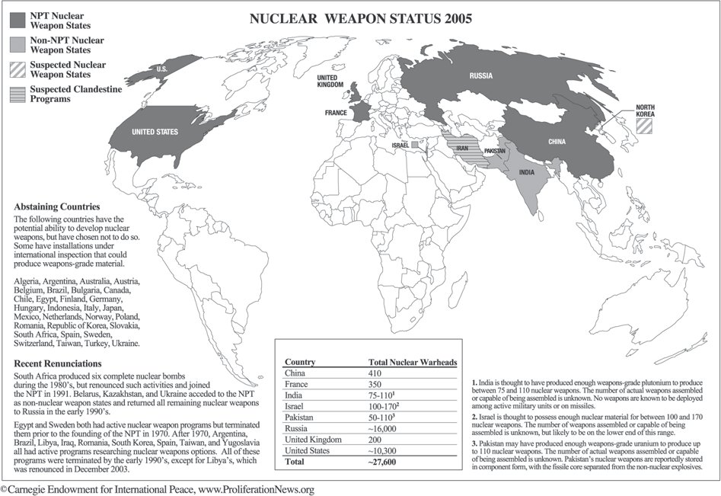

stated that the agencies “do not know whether [Iran] currently intends to develop nuclear weapons.” This finding has not quieted con- cern about the possibility of a nuclear armed Iran. The Iranian government has claimed that it has the right to develop nuclear materials for peaceful purposes. The dilemma for the in- ternational community is that it is difficult to distinguish between “good atoms” for peaceful purposes and “bad atoms” for military pur- poses.
Reprinted with permission.
In a move supported by Washington and Europe, Russian officials proposed supplying Iran with fuel for its nuclear power plants that could be used only for peaceful purposes. Nev- ertheless, in 2006 Iran restarted its uranium enrichment program in a move that heightened concern around the world. The International Atomic Energy Agency (IAEA) referred Iran to the UN Security Council for possible punitive action in early 2006. Iran has threatened to withdraw completely from the NPT. France, Germany, and the United Kingdom have nego- tiated closely with Iran to encourage it to end
its nuclear program. Iran’s new conservative, hardline president, Mahmoud Ahmadine- jad, has staunchly defended Iran’s right to a nuclear program. His public assertion that Israel should be “wiped off the map” has also heightened international anxiety about Iran’s intentions.

Libya: In December 2003, Libya an- nounced that it would allow arms inspectors from the UN unfettered access to its weapons programs. Diplomatic relations between the
  - and Libya, which had been cut off since 1981, were reestablished in 2004. Libya was considered a leading sponsor of terrorism, including bombing Pan Am flight 103 over Lockerbie, Scotland in 1988. Experts were aware of operational chemical weapons in Libya but were not sure of the extent of the nuclear and biological programs.
Evidence suggests that Libya had received design information from Pakistan and bomb materials from North Korea, two states at the

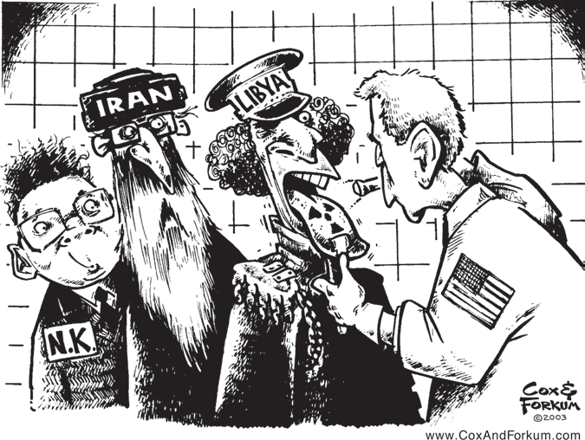
center of proliferation concerns.
Although some were surprised by Libya’s announcement, others note that Libya had been making efforts to reha- bilitate itself in the eyes of the world for several years. For example, in 1999 Libya turned over the suspects in the Lock- erbie bombing, and in 2003 Libya agreed to pay several billion dollars to compensate the victims’ families. There is debate about why Libya decided to give up its weapons program. Experts have discussed the role that
Reprinted with Permission.
various factors including incentives, economic sanctions, and military threats played. Libya’s strong steps suggest that international efforts to control proliferation and reform the behav- ior of states can work.

n this section you have read about the leading security issues of the day and how U.S. foreign policy has tried to confront them. In Part II, you read about today’s leading economic, environmen-
I
tal, political, and cultural issues and how globalization has presented new opportunities and new difficulties to people around the world. As these readings make clear, the world is full of complexi- ties and challenges. Together, Parts II and III provide you with new tools to evaluate the world around you.
In Part I, you read about three previous turning points in our nation’s history. You are now chal- lenged to consider whether the United States is at a new turning point, and, if so, what direction you believe it should take in the next decade and beyond. What issues are of most concern to you? What do you think we should do about these issues? What kind of world do you want in the twenty-first century? In the coming days, you will explore four distinct alternatives—or Futures. They are de- signed to help you think about a range of possible policy alternatives, the ramifications of each, and the risks and trade-offs involved. The four Futures provided are not intended as a menu of choices. Rather, they are framed in stark terms to highlight very different policy approaches. Each alterna- tive includes a set of policies on specific issues, an overview of the beliefs that underlie it, and some arguments in support of the position and some criticisms of it. At the end of this reading, you will be asked to make your own choices about where our country should be heading. You are also invited to participate in an online ballot on this subject. It can be found at <www.choices.edu/usroleballot>.

Future 1: Lead the World to Democracy

Futures in Brief
Future 3: Build a More Cooperative World

The United States is the most powerful na- tion in the world. The world depends on us to maintain peace and order and to support liber- al democratic principles. Today’s international system was built around American ideals and power. Neither collective security nor the United Nations can be counted on to deal with the threats to this system. We must devote the necessary resources to build an international moral order and a vigorous international economy grounded in American political and economic principles and we must protect
this international system from any threats, even if pressuring other governments to adopt American democratic principles may spark international criticism that the United States is trying to control the world.

Future 2: Protect U.S. Global Interests
We live in a dangerously unstable world.
U.S. foreign policy must strive for order and security. International terrorism, chaos in the Middle East, rising poverty in the develop- ing world, and global economic competition have created an international minefield for
U.S. leaders. We need to focus our energies on protecting our own security, cultivating our key trade relationships, ensuring our access to crucial raw materials, and stopping the spread of nuclear weapons to unfriendly nations or to terrorist networks. We must be selective in our involvement in international affairs and
be prepared to protect ourselves—at home and abroad—against any threats to our security and prosperity, even if this policy may breed resentment and lead to an angry backlash against us.
We live today in an interdependent and interconnected world. We cannot stand alone. National boundaries can no longer halt the spread of HIV/AIDS, international drug traf- ficking, terrorism, and other global scourges. We must take the initiative to bring the nations of the world together and play a leadership role in strengthening the UN’s role in interna- tional security and responding to other global problems such as environmental pollution, financial crises, refugees, and AIDS. We must be willing to give up a portion of our indepen- dent authority, or sovereignty, to the UN and offer our military, intelligence, and economic support to UN-led initiatives, even if this may limit our ability to use military force unilater- ally outside of North America.

Future 4: Protect the
  - Homeland
The attacks of September 11, 2001 have made us feel a vulnerability not felt in more than fifty years. We have spent hundreds of billions of dollars a year defending our allies in western Europe and East Asia and distrib- uted tens of billions more in foreign aid to countries throughout the developing world. These high-profile foreign policy programs have only bred resentment against us and made us enemies. It is time to sharply scale back our foreign involvement and turn our attention to the real threats facing Americans: a sagging economy, decaying schools, a shaky health care system, and inadequate resources to protect against terrorism, even if this may upset the worldwide balance of power and cause insecure countries to seek nuclear, bio- logical, and chemical weapons.

Future 1: Lead the World to Democracy
T
he United States is the most powerful nation in the world. The world depends on us to maintain peace and order and to support the principles of democracy, free
markets, and freedom. We must acknowledge and embrace the important role we play. Today’s international system was built around American ideals and power. International security structures are primarily a result of American-led alliances. Americans created the international financial institutions in place today. International principles of human rights are actually American and Western European ideas. We must devote the necessary
resources to build and maintain an international order and a vigorous international economy grounded in American political and economic principles. These American values are the standard by which all other systems should be measured. U.S. actions abroad must reflect our country’s commitment to our core principles of freedom, justice, and democracy.

Many states remain in the hands of cruel and undemocratic leaders who terrorize their own people, threaten their neighbors, and breed unrest around the world. Such tyrants pose a danger to global peace and security. Neither collective security nor the United Nations can be counted on to deal with these threats. When it comes to dealing with tyrants, especially with those that are a threat to security, our policy should not be one of coexistence, but transformation. We must be prepared to
attack those who threaten us before they can attack us. Acting preventively is the only way that we will be able to protect ourselves and other friendly states.

Future 1 is based on the following beliefs

    - We have a special responsibility to promote and protect American values around the world, even if we have to act alone.
    - Our military should not be afraid to keep troublemakers in check and spread liberal democratic principles throughout the world.
    - Tyrannical regimes are the main human
cause of suffering in the world. To support them or turn a blind eye to their repression and aggression is both dangerous and immoral.
    - A world grounded in American economic and political principles will strengthen our economy and make us more secure.

What policies should we pursue?
      - Use a policy of regime change to transform authoritarian states into democratic ones. Provide resources to developing democracies and ensure their success.
      - Develop a sophisticated missile defense system.
      - Persist in executing the War on Terror by leading a worldwide offensive.

    - Impose trade boycotts on countries that do not adopt American political and economic principles.
    - Eliminate obstructive government policies related to the environment.
    - Promote American culture and values abroad.

- As the events in Afghanistan and Iraq have shown, aggressive tyrants and oppressive regimes will be stopped only when the United States intervenes decisively to change these regimes.
- If we wait until the world’s bullies become so powerful that we must confront them militarily, as we did with Adolf Hitler in World War II, the cost will be enormous.
- Since democracies are much less likely to start wars against other democracies, we will be making the world a more peaceful place in the long run by spreading democratic values.
- As new democracies take root and their economies prosper, they will become strong trading partners for the United States.
- Pressuring other governments to adopt American democratic principles will spark international criticism that the United States is trying to control the world.
- Engaging in regular efforts at regime change will ensure that we will be seen as the “rogue superpower” and others will line up against us. Using force preventively will only make this worse.
- Stressing the division between democratic and undemocratic countries will split the world into two opposing camps, as in the Cold War. Valuable allies, such as Saudi Arabia, will be lost while emerging powers in the developing world, such as China, will be branded as enemies.
- Refusing to trade with undemocratic countries will only hurt the U.S. economy, since by doing so the United States will cut itself off from vital sources of oil and other raw materials.
- You can’t force other nations to establish democracies. Many societies in the Middle East, the developing world, and the former Soviet bloc reject our definitions of democracy and human rights.

Future 2: Protect U.S. Global Interests
W
e live in a dangerously unstable world. U.S. foreign policy must strive for order and security. International terrorism, chaos in the Middle East, poverty and despair in
the developing world, and global economic competition have created an international minefield for U.S. leaders. In order to navigate successfully through these unpredictable times we cannot be distracted by crusading idealists—either those who want to impose American-style democracy on the world or those who think that everyone can cooperate to solve the world’s problems. Nor can our interests be curtailed by shortsighted isolationists. We should remain actively involved in international affairs and be prepared to protect ourselves—at home and abroad—against any threats to our security and prosperity.

To promote U.S. interests, we must engage with the world selectively. We must focus our energies on protecting our own security, cultivating our key trade relationships,
ensuring our access to crucial raw materials, and stopping the spread of nuclear weapons to unfriendly nations or to terrorist networks. Whenever possible, we should use our influence to engage other nations so that we do not have to shoulder the load alone.
However, when this fails we must be ready and able to act—alone if necessary—to protect ourselves against any threats to our security and prosperity. Americans have no choice but to accept the world as it is and respond pragmatically and selectively with whatever actions are necessary to keep our country safe and strong.

Future 2 is based on the following beliefs

  - Protecting our economic and security interests worldwide is more important than promoting lofty ideals. When our interests are threatened we have the right to defend ourselves with military force.
  - International stability and security depend largely on the United States. The United States has the strength to keep power-hungry nations in check and to build

What policies should we pursue?
  - Build alliances with other countries to protect our interests and security abroad.
  - Increase the flexibility of our military so that it can respond quickly to threats worldwide.
  - Take the War on Terror to any nation that harbors international terrorists. Engage others in our efforts where possible but act alone when necessary,
coalitions to maintain stability in volatile regions.
    - The United States, like most other countries, benefits from stability. Efforts to change the international system inevitably backfire, resulting in disorder and conflict.
    - Unsavory as it may seem, U.S. interests often require that we maintain friendly relations with undemocratic governments such as Saudi Arabia and China.

    - Use economic and military aid to advance U.S. trade and investment in the former Soviet bloc and the developing world.
    - Pursue “green” technologies and products, but also require other nations to protect the environment so that we do not lose our competitive edge.

- Maintaining our long-standing military alliances in western Europe, the Middle East, and East Asia will help protect U.S. interests and put today’s shaky international system on firm ground.
- U.S. involvement in unstable areas such as the Middle East and the Korean peninsula will reduce the possibility of war. In a more stable international environment, countries will be less likely to seek to acquire nuclear, biological, and chemical weapons.
- A forceful but selective U.S. presence in international affairs will discourage emerging powers, such as China, from building up their military might and expanding their influence at the expense of their neighbors.
- By keeping human rights issues from interfering with our business interests, the United States will gain new markets for our products and enjoy access to the raw materials and inexpensive manufactured goods critical to our economic prosperity.
- Acting only in our own interest and without regard for other nations’ interests and cultures breeds resentment against the United States. This will lead to an angry backlash against us, risking international violence
and undermining international cooperation on critical global issues such as stopping terrorism, controlling nuclear weapons, and cleaning up pollution.
- Maintaining our alliances with cruel dictators sets back the cause of human rights and the worldwide movement toward democracy.
- Intervening only where our immediate self interests are at stake will mean turning our back on future incidents of genocide and “ethnic cleansing,” as was the case in Bosnia and Rwanda.
- An interventionist U.S. foreign policy distracts politicians from the issues that they should focus on here at home.
- As World War I showed, balance-of- power schemes eventually collapse. Similarly, if we had not armed Iraq in the 1980s to keep Iran in check, Saddam Hussein would not have emerged as an international menace.

Future 3: Build a More Cooperative World
T
oday’s world is interdependent and interconnected. We cannot stand alone. National boundaries can no longer halt the spread of HIV/AIDS, international drug trafficking,
terrorism, and other global scourges. Environmental problems threaten the ecology of the entire planet. Financial panic spreads like wildfire with the speed of the internet. Political upheaval anywhere in the world can send waves of refugees to U.S. shores.

To live securely and peacefully in this interdependent world, we must take the initiative to bring the nations of the world together. We should lead efforts to strengthen the UN and
other regional security organizations by contributing to their efforts to maintain global peace, fight terrorism, address humanitarian crises, and enforce sanctions against countries that violate the standards of the international community. We must be willing to give up a portion of our independent authority, or sovereignty, to the UN and offer our military, intelligence, and economic support to UN-led initiatives. We should use military force outside of North America only under the leadership of the UN or other regional security institutions in
which we participate. In addition, we should join with Japan, western Europe, and other wealthy allies to help the countries of Asia, Africa, and Latin America lift themselves out of poverty. Building a more cooperative world will not be easy. In the end, however, we must recognize that our fate as Americans is bound together with the fate of all of humanity.

Future 3 is based on the following beliefs

  - We live in an interdependent world. We must work cooperatively to address global problems that affect us all, such as international terrorism, the destruction of tropical rain forests, refugee crises, deadly epidemics, and nuclear proliferation.
  - A unilateralist U.S. foreign policy will only fuel anti-American sentiment around the world. We must share decisionmaking and leadership with the community of nations.
  - It is the responsibility of wealthier

What policies should we pursue?
  - Engage in military action abroad only with the cooperation or approval of the UN or another regional institution.
  - Increase support for international agreements such as the Comprehensive Test Ban Treaty and the International Criminal Court.
  - Pursue the War on Terror through the UN. Work with allies to freeze the assets of suspected terrorist organizations.
nations to assist impoverished ones. Good global citizenship will bear positive returns for us economically, politically, and for our security.
    - The earth does not belong to us. Americans comprise less than 5 percent of the world’s population, and the United States is but one of nearly two hundred countries in the world. Our country does not have the right to dominate the rest of the world.

    - Spearhead international efforts to establish regulations to protect developing economies from the ups and downs of the global financial system.
    - Work with others to achieve a globally sustainable balance of development and environmental preservation. In exchange for cooperation on environmental issues, forgive the debt poor countries owe us.

- Giving more power and authority to international organizations does not make us powerless. On the contrary, by bringing nations together to solve common problems, we will gain the strength to deal with the world’s challenges.
- By working through international organizations, the United States will change the nature of the international system.
Cooperation, not conflict, will come to be accepted as the basis for international relations.
- The economic assistance we gave Western Europe and Japan after World War II helped boost international trade and strengthen the U.S. economy. Aiding the countries of the developing world and the former Soviet bloc will likewise benefit the United States in the long run.
- Strengthening the UN and other international institutions will help firmly anchor Russia, China, and other unpredictable powers in a setting of cooperation and responsible behavior.
- By handing over power to international organizations, we will lose much of our international influence. China, Japan, Russia, and other leading powers will take advantage of our cooperative spirit to make themselves stronger at our expense.
- Our fundamental values are in conflict with those of large parts of the world. Cooperation not only won’t work, it could be dangerous.
- Constraining our ability to use military force unilaterally outside of North America will limit our ability to defend ourselves
and respond to international events and will encourage our enemies. International
organizations are too slow, too ineffective, and cannot be counted on to act when vital U.S. interests are at stake.
- Many countries are run by corrupt and cruel governments. Strengthening international organizations in which thieves and tyrants have a voice and giving them
more foreign aid will only make such regimes stronger.
- Spending billions of dollars trying to solve the world’s ills will deprive us of the resources we need to address the many problems we face at home.

Future 4: Protect the U.S. Homeland
T
he attacks of September 11, 2001 brought a new message to Americans. We were attacked on our own homeland and we feel a vulnerability not felt in more than fifty
years. Since the late 1940s, the United States has spent hundreds of billions of dollars a year defending our allies in western Europe and East Asia, and distributed tens of billions more in foreign aid to countries throughout the developing world. And what do we have to show for our efforts? Our high-profile foreign policy programs have only bred resentment against us and made us enemies. Our recent military involvement overseas—most
notably in Iraq—makes this situation even worse. When we took the initiative to remove Saddam Hussein from power in Iraq, even our traditional allies turned against us.

Enough is enough. We must make it clear that the United States can no longer be counted on to solve the world’s problems. It is time to turn our national attention to the real threats facing Americans: a sagging economy, loss of jobs, decaying schools, a shaky health care system, and inadequate resources to protect against terrorism. We must sharply scale back our foreign involvement. U.S. troops overseas should be brought home and strict limits put on military spending. We have to put our own needs first.

Future 4 is based on the following beliefs

  - A nation’s first responsibility is to defend its citizens from harm. Focusing on other countries’ problems is a waste of precious resources at a time when those resources are needed at home.
  - Most of the problems afflicting the world beyond U.S. borders cannot be solved by the

What policies should we pursue?
  - Phase out our alliances outside of North America and make it clear that we will join other countries militarily only when our security is directly threatened.
  - Redesign our armed forces to focus on defending North America and build up our intelligence capacity with a focus on
understanding the threats that face us here at home. Stay out of conflicts that do not concern us directly.
  - Develop defenses to be used at home against potential biological, chemical, or nuclear attacks by terrorists.
United States, and meddling overseas will make us more enemies than friends.
    - International power and influence in today’s world are measured in terms of
economic strength, not military might. The military and foreign entanglements that the United States built up during the Cold War are now a burden on our country.

    - Protect American industries from unfair foreign competition and American jobs from cheap foreign labor. Reduce our dependence on foreign oil by encouraging American oil companies to invest at home and by promoting alternative sources of energy and energy conservation.
    - Do not hamstring our economy with environmental restrictions while allowing the emerging powers of the developing world a free ride.

- By not interfering in other parts of the world where our presence may not be
welcome, we will avoid unnecessary conflicts or making ourselves the target of resentment.
- Eliminating costly and ill-conceived foreign policy ventures—such as building democracy in Iraq or lifting sub-Saharan Africa out of poverty—will free up resources needed within our own borders.
- By giving top priority to our domestic problems, we will be in a much better position to serve as a model for other countries.
- Sharply cutting U.S. military spending will encourage other leading powers to reduce their spending on defense and will lower tensions worldwide.
- We cannot afford to abandon our commitments around the world. Regions of the world where we had a strong presence will become unstable, and as our strength abroad declines, those who oppose us will see an opportunity to increase anti-American terrorist activity.
- Pulling our troops out of western Europe, the Middle East, and East Asia will upset the worldwide balance of power and spark wars. In response, countries such as South Korea will seek to acquire WMD in order to provide for their own defense.
- Deeply cutting our military power will leave the United States incapable of standing up for democracy or protecting our security and economic interests. As in World War II, the United States will eventually be forced to undertake a costly military build-up to combat threats from overseas.
- The Persian Gulf War showed us that economic sanctions have their limits, and that military strength is still a decisive factor in shaping the world. If we sharply cut our military spending, we will be unable to defeat the next evil tyrant that crosses us.
- Pretending that the fate of the rest of the world matters little is foolish and dangerous. International terrorism can threaten any country at any time. And if a country such
as Russia, with its huge arsenal of nuclear weapons and vast reserves of raw materials, tilts in the wrong direction, the United States will pay a terrible price.

Study Guide—Part I
- Give three reasons why Americans became interested in the Cuban struggle for independence. a.

b.

c.

- Name the new territories the United States controlled following the Spanish-American War.

  - c.

  - d.

- Summarize the arguments supporting and opposing imperialism at the start of the twentieth cen- tury.

Supporting:

Opposing:

- Why did the Senate oppose U.S. membership in League of Nations after World War I?

- Why did many Americans wish to insulate themselves from Europe in the 1920s and 30s?

Changing World
6
Day One
Name:

- When American policymakers considered the situation in Europe after World War II, they deter- mined that the United States could not isolate itself from world affairs. What was happening in these countries that led them to think this?

  - Britain:

  - France, Germany, Italy:

  - Soviet Union:

- What was the “iron curtain” Churchill referred to?

- Define “containment” and offer an example of U.S. policy to “contain” the Soviets.

- Define “deterrence” and offer an example of U.S. policy which attempted to “deter” the Soviets.

hanging World
8
Graphic Organizer
Name:

Legacies of Historical Turning Points

Instructions: In the boxes below, indi- cate first what issues were debated in the given time period. Next, indicate what policies were finally implemented and what values those policies represented.
Finally, write down the lessons learned from the events and make a check mark next to those lessons you think today’s leaders should consider as they
craft U.S. foreign policy.

Post Spanish-American War
Issues debated: 1.

2.

3.

4.

Policies: Values:
 | Post World War II
 | Issues debated: | Lessons learned:
 | 1. | 1.
 | 2. | 2.
 | 3. | 3.
Lessons learned:
1. | 4. | 4.
2. | Policies: | Values:
3.
4.
Extra challenge: What values drive our current

foreign policy decisions?

Post World War I
Issues debated:
1. 3.

2. 4.
Policies: Values:

Lessons learned:
1. 3.

2. 4.

Name:

International Relations Terminology
Changing World
Day One
9

Instructions: Your group has been assigned a selection of terms. For each term, come up with a working definition with your group. Be prepared to explain and defend your definitions with the rest of the class.

Economy
per capita income

developing countries

developed countries

globalization

free trade

economic sanctions

Human Health and the Environment
environmental destruction

malnutrition

malaria

HIV/AIDS

greenhouse effect

“green” technology

Changing World
10
Day One

International Relations
security

freedom

democracy

European Union

political instability

international organizations

Culture and Values
religion

culture

Americanization

human rights

equality

liberty
Name:

Rethinking International Relations: Six Perspectives

Introduction: In the last few years Americans have rethought their role in international relations.
The end of the Cold War, the growth of globalization, and the terrorist attacks of September 11th, 2001 changed many of our fundamental assumptions about the way the world works and sparked far-reaching debate. Below, you will read selections from articles and books that have shaped the
discussion. The six selections present a range of opinions about the nature and direction of the inter- national system today. As you read each of them, consider the following questions:
  - According to the author, what are the most important forces shaping the twenty-first century?
  - According to the author, what are the main foreign policy challenges facing the United States in the twenty-first century?
After you have read the selections and discussed them with classmates, you will be asked to develop your own ideas about the direction of the international system. Use the questions above to organize your thoughts.

Selection 1

The Clash of Civilizations?
by Samuel P. Huntington, in Foreign Af- fairs, Summer 1993
It is my hypothesis that the fundamental source of conflict in this new world will not be primarily ideological or primarily economic.
The great divisions among humankind and the dominating source of conflict will be cultural. Nation states will remain the most power-
ful actors in world affairs, but the principal conflicts of global politics will occur between nations and groups of different civilizations. The clash of civilizations will dominate global politics. The fault lines between civilizations will be the battle lines of the future.
A civilization is...defined both by common objective elements, such as language, history, religion, customs, institutions, and by the sub- jective self-identification of people.
Civilization identity will be increasingly important in the future, and the world will be shaped in large measure by the interac-
tions among seven or eight major civilizations. These include Western, Confucian, Japanese, Islamic, Hindu, Slavic-Orthodox, Latin Ameri- can and possibly African civilization. The most important conflicts of the future will occur along the cultural fault lines separating these civilizations from one another.
Selection 2

The Lexus and the Olive Tree
by Thomas Friedman, 1999
The globalization system, unlike the Cold War system, is not static, but a dynamic ongoing process: globalization involves the
inexorable integration of markets, nation-states and technologies to a degree never witnessed before—in a way that is enabling individu-
als, corporations and nation-states to reach around the world farther, faster, deeper and cheaper than ever before, and in a way that is also producing a powerful backlash from those brutalized or left behind by this new system…. Culturally speaking, globalization is largely, though not entirely, the spread of American- ization—from Big Macs to iMacs to Mickey Mouse—on a global scale….
…The Lexus and the olive tree [are] actu- ally pretty good symbols of this post-Cold War era: half the world seems to be emerging from the Cold War intent on building a better Lexus, dedicated to modernizing, streamlining, and privatizing their economies in order to thrive in the system of globalization. And half the world—sometimes half the same country, sometimes half the same person—[is] still caught up in the fight over who owns which olive tree….
The challenge in this era of globalization—

Name:
Changing World
Day One-Alternative Lesson
13

for countries and individuals—is to find a healthy balance between preserving a sense of identity, home and community and doing what it takes to survive within the globaliza- tion system.

Selection 3

The Paradox of American Power
by Joseph S. Nye, Jr., 2002
The United States is undoubtedly the world’s number one power, but how long can this situation last, and what should we do with it?…
Pax Americana is likely to last not only because of unmatched American hard power [wealth, military might, the ability to com- mand] but also to the extent that the United States is uniquely capable of engaging in ‘strategic restraint,’ reassuring partners and facilitating cooperation. The open and plural- istic way in which our foreign policy is made can often reduce surprises, allow others to have a voice, and contribute to our soft power [inspiration, influence, the ability to attract]. Moreover, the impact of American preponder- ance is softened when it is embodied in a web of multilateral institutions that allow others to participate in decisions and that act as a sort of world constitution to limit the capriciousness of American power.
…Failure to pay proper respect to the opinion of others and to incorporate a broad conception of justice into our national interest will eventually come to hurt us.
…Many of the transnational issues— whether financial flows, the spread of AIDS, or terrorism—cannot be resolved without the cooperation of others. Where collective action is a necessary part of obtaining the outcomes we want, our power is by definition limited and the United States is bound to share.

Selection 4

The Clash of Globalizations
by Stanley Hoffman, in Foreign Affairs, July 2002
…Many scholars today interpret the world in terms of a triumphant globalization
that submerges borders through new means of information and communication. In this
universe, a state choosing to stay closed invari- ably faces decline and growing discontent among its subjects, who are eager for material progress. But if it opens up, it must accept a reduced role that is mainly limited to social protection, physical protection against aggres- sion or civil war, and maintaining national identity. The champion of this epic without heroes is The New York Times columnist Thomas Friedman…The real universe of globalization does not resemble the one that Friedman celebrates….
Globalization, far from spreading peace,
…seems to foster conflicts and resentments. The lowering of various barriers celebrated by Friedman, especially the spread of global
media, makes it possible for the most deprived or oppressed to compare their fate with that of the free and well-off. These dispossessed then ask for help from others with common resent- ments, ethnic origin, or religious faith. Insofar as globalization enriches some and uproots many, those who are both poor and uprooted may seek revenge and self-esteem in terrorism.

Selection 5

A New War of the World
by Niall Ferguson, in Foreign Affairs, Sep- tember 2006
The twentieth century was the bloodiest era in history. ...In all, between 167 million and 188 million people died because of orga- nized violence in the twentieth century—as many as one in every 22 deaths in that pe- riod….
Will the twenty-first century be as bloody as the twentieth? The answer depends partly on whether or not we can understand the causes of the last century’s violence. Only if we can will we have a chance of avoiding a repetition of its horrors. If we cannot, there is a real possibility that we will relive the night- mare....
Three factors explain the timing and the location of the extreme violence of the twen- tieth century: ethnic disintegration, economic

volatility, and empires in decline. ...If the com- bination of ethnic disintegration, economic volatility, and empires in decline is the basic formula for twentieth-century conflict, then what are the implications for the twenty-first century?
...Today, one region displays in abundance all of the characteristics of the worst conflict zones of the twentieth century. Economic volatility has remained pronounced there even as it has diminished in the rest of the world.
An empire (albeit one that dares not speak its name) is losing its grip over the region. Worst of all, ethnic disintegration is already well un- der way, even though many commentators still conceive of what is currently the main conflict there as an insurgency against foreign invaders or a “clash of civilizations” between Islam and the West. That place is the Middle East.
The Middle East … has the misfortune to be a zone of imperial conflict. Most Americans will probably always reject the proposition that the United States is (or operates) a de facto empire. Such squeamishness may be an integral part of the U.S. empire’s problem. To be an empire in denial means resenting the costs of intervening in the affairs of foreign peoples and underestimating the benefits of doing so.
In 1993, Harvard’s Samuel Huntington pre- dicted that in the post-Cold War world, “the principal conflicts of global politics [would] occur between nations and groups of different civilizations,” particularly between a decadent “Judeo-Christian” West and a demographically ascendant Islamic civilization. For a time, events seemed to be fulfilling his prophecy.
Many Americans interpreted the terrorist at- tacks of September 11, 2001, in Huntington’s terms, while Islamists interpreted the U.S. invasions of Afghanistan and Iraq as wars by Christian “crusaders” against Muslims.
Yet a closer inspection of events since 1993 suggests a post-Cold War trend of clashes within, rather than between, civilizations...
Events in Iraq suggest that there, too, what is unfolding is not a clash between the West and Islam but, increasingly, a clash within
Islamic civilization itself. If the history of the twentieth century is any guide, only economic stabilization and a credible reassertion of U.S. authority are likely to halt the drift toward chaos. Neither is a likely prospect…The sober- ing possibility we urgently need to confront is that another global conflict is brewing today- centered not on Poland or Manchuria, but more likely on Palestine and Mesopotamia.

Selection 6

The Clash of Emotions: Fear, Humiliation, Hope, and the New World Order
by Dominique Moïsi, in Foreign Affairs, January 2007
Thirteen years ago, Samuel Huntington argued that a “clash of civilizations” was about to dominate world politics, with culture, along with national interests and political ideology, becoming a geopolitical fault line... Events since then have proved Huntington’s vision more right than wrong. Yet what has not been recognized sufficiently is that today the world faces what might be called a “clash of emo- tions” as well. The Western world displays a culture of fear, the Arab and Muslim worlds are trapped in a culture of humiliation, and much of Asia displays a culture of hope.
Instead of being united by their fears, the twin pillars of the West, the United States and Europe, are more often divided by them— or rather, divided by how best to confront or transcend them. The culture of humiliation, in contrast, helps unite the Muslim world around its most radical forces and has led to a
culture of hatred. The chief beneficiaries of the deadly encounter between the forces of fear and the forces of humiliation are the bystand- ers in the culture of hope, who have been able to concentrate on creating a better future for themselves.
These moods, of course, are not universal within each region, and there are some areas, such as Russia and parts of Latin America, that seem to display all of them simultaneously.
But their dynamics and interactions will help shape the world for years to come.

Study Guide—Part II

- What is globalization?

- Give two reasons why some people are fearful of globalization. a.

b.

- Give one positive and one negative effect of economic globalization.

Positive:

Negative:

- Supporters and critics have different views on who benefits most from free trade.

  - According to supporters, who benefits?

  - According to critics, who benefits?

- Name three health concerns that are widespread and especially deadly. a.
b.

c.

Name:
Changing World
Day Two
17

- What are the primary differences between developed (northern) countries and developing (south- ern) countries on global environmental issues?

Environmental Conditions  Northern Countries | Use of Resources | Contributions to Pollution | Population Growth
Southern Countries

- What is the current stance of the United States toward environmental regulation?

- Why does the United States wish to promote democracy in other countries?

- What is an international organization? Give three examples that support your definition.

- Why do some people call for reform of the structure of the UN? What problems do they see?

- What are human rights? Why do some nations resist an international human rights standard?

- Look at the Universal Declaration of Human Rights table on page 17. List two rights included in the amendments to the U.S. Constitution and two which do not appear.

In the Constitution: Not in the Constitution:

The U.S. Role in a Changing World Graphic Organizer
TRB
19
Name:
www.choices.edu
watson institute for international studies, Brown university
choices for the 21st century education Program
■
■
■

Global Issues on the U.S. Agenda

 | How does globalization affect this issue? | What are the top U.S. concerns about this issue? | What are the top concerns of other nations about this issue?  industrialized developing |  | What policies does the United States have in place regarding this issue?
Economy
Environment
Health
International Relations
Culture and Values

Pew Graphs 1: Democracy
Basic Needs vs. Basic Rights:
Little Consensus on What Is Most Important
U.S.
Canada
Argentina Bolivia Brazil Chile Mexico Peru Venezuela
Britain France Germany Italy Spain Sweden
Being free to speak publicly
% 18
21
19
35
18
26
33
38
44
18
24
36
39
34
24
Being free Being free Being free to practice from hunger from crime
religion
%
28
11
3
13
8
6
15
10
7
7
4
6
12
4
4
& poverty
% 22
33
45
28
40
36
22
24
18
40
56
30
18
44
41
& violence
%
28
33
32
24
34
32
29
28
31
33
17
26
27
17
28
DK
% 4
2
0
1
0
1
1
0
0
1
0
2
4
1
3
Percent in each country that name freedom or condition as most important to them of the four tested. The freedom or condition that was selected by the largest percentage in each country is in bold.
*Not offered as a response category in China.
Asked only in developing countries.
% saying it is “very important” to them to live in a country where citizens have that right.
Senegal (65) Jordan (3)
Ivory Coast (58) Kuwait (15)
Lebanon (57) Indonesia (17)
Civilian control of the military
Malaysia (32)
Indonesia (33)
Bolivia (36)
Egypt (75)
Ethiopia (73)
Lebanon (72)
Media free from govt censorship
Malaysia (33)
Russia (34)
Kuwait (37)
Lebanon (86)
Egypt (80)
Tanzania (73)
Free speech
Indonesia (39)
Russia (41)
Bolivia (41)
elections Ivory Coast (77) Senegal (77)
Honest multiparty Lebanon (81)
China (48)
Bolivia (48)
India (52)
Impartial judiciary Ethiopia (91)
Egypt (88)
Tanzania (87)
Least
%
Russia (45)
Czech Rep. (48)
Bolivia (48)
Most
%
Religious freedom Senegal (95)
Ethiopia (92)
Tanzania (92)
Where Key Democratic Principles Are Valued the Most, Least
1. 2.

Questions to Consider:
The Pew Global Attitudes Project. Reprinted with permission.
Bulgaria | 11 | 1 | 59 | 28 | 1
Czech Rep. | 16 | 4 | 38 | 40 | 1
Poland | 21 | 12 | 44 | 21 | 1
Russia | 19 | 6 | 42 | 30 | 3
Slovakia | 18 | 5 | 42 | 33 | 2
Ukraine | 18 | 5 | 52 | 24 | 1
Turkey | 26 | 29 | 29 | 15 | 1
Egypt | 26 | 25 | 34 | 15 | 1
Jordan | 20 | 29 | 24 | 27 | 1
Kuwait | 36 | 29 | 14 | 20 | 0
Lebanon | 38 | 15 | 23 | 24 | 0
Morocco | 20 | 25 | 40 | 13 | 2
Palest.ter. | 39 | 26 | 21 | 12 | 2
Israel | 30 | 23 | 29 | 18 | 1
Pakistan | 18 | 41 | 27 | 8 | 7
Bangladesh | 23 | 42 | 20 | 16 | 1
Indonesia | 8 | 37 | 45 | 9 | 1
Malaysia | 10 | 24 | 23 | 44 | 0
China | 19 | N/A* | 42 | 36 | 3
India | 41 | 22 | 22 | 14 | 1
Japan | 44 | 3 | 16 | 34 | 2
S. Korea | 44 | 8 | 22 | 20 | 6
Ethiopia | 14 | 26 | 53 | 7 | 0
Ghana | 19 | 10 | 54 | 17 | 0
Ivory Coast | 24 | 32 | 27 | 18 | 0
Kenya | 12 | 12 | 55 | 21 | 0
Mali | 20 | 29 | 39 | 12 | 0
Nigeria | 23 | 30 | 36 | 10 | 0
Senegal | 10 | 43 | 36 | 11 | 0
S. Africa | 20 | 19 | 29 | 32 | 0
Tanzania | 28 | 22 | 43 | 7 | 0
Uganda | 22 | 14 | 47 | 16 | 1

  - What information is shown in the tables?

  - Table #1 shows statistics for different re- gions of the world. Are there trends within each region? Are there trends between regions?
The Pew Global Attitudes Project. Reprinted with permission.

  - Using Table #1, find an example of a country in which there is a high level of agreement about what right or need is most impor- tant. Find an example of a country in which there is very little agreement about what is most important.

  - According to Table #2, among developing countries, which region most values democratic prin- ciples?

  - In Table #1, a majority of countries value freedom from hunger and poverty more than the other rights and needs that are listed. Why might this be the case?

The Pew Global Attitudes Project. Reprinted with permission.

Pew Graphs 2: Modernity
The Young Are Less Worried About Foreign Influence
U.S.
Young-old
18-39 40+ gap
% % %
53 68 -15
Britain
Italy
Bulgaria Poland Ukraine Russia Slovakia Czech Rep.
Japan
79
64
55
68
73
70
77
55
81
76
66
78
80
68
73
70
-2
-12
-11
-10
-7
+2
+4
-15
Percent agree that “Our way of life needs to be protected against foreign influence.”

U.S. | 73 | 62 | Canada | 56 | 64 | -8
Canada | 71 | 62
 |  |  |  | 45 | 59 | -14
Bolivia 76 66 Sweden |  |  |  | 20 | 33 | -13
Brazil 84 77 Germany |  |  |  | 45 | 57 | -12
Chile 84 71 Spain |  |  |  | 66 | 77 | -11
Mexico 81 75 France |  |  |  | 45 | 56 | -11

regions have the highest? Why might this be so?
Concerns About Losing Our Way of Life

Our way of life…
is being must be
lost protected
% %
Argentina
86
70
Peru Venezuela
Britain France Germany Italy Spain Sweden
Bulgaria Czech Rep. Poland Russia Slovakia
79
80
77
75
74
70
79
49
63
76
77
65
75
50
52
54
52
53
80
72
29
71
74
62
77
69
Mali Nigeria Senegal
South Africa Tanzania Uganda
94
88
83
76
89
85
77
80
85
85
90
76
The Pew Global Attitudes Project. Reprinted with permission.
Ukraine | 67 | 74
Turkey Egypt | 67  56 | 88  88 | Questions to Consider:  1. What information is shown in the tables?
Jordan | 53 | 81
Kuwait | 78 | 79
Lebanon | 69 | 75
Morocco | 78 | 78
Palest. ter. | 51 | 79
Israel | 56 | 72
Pakistan  Bangladesh | 74  92 | 81  82 | 2. Which region of the world seems to have the lowest percentage
Indonesia Malaysia | 59  66 | 88  85 | of people worried about protecting their way of life? Which
China | 60 | 70
India | 70 | 92
Japan | 74 | 64
South Korea | 92 | 70
Ethiopia | 82 | 85
Ghana | 85 | 80
Ivory Coast | 86 | 81
Kenya | 87 | 89

3. What are some reasons why young people in certain countries might be less worried than older people about foreign influ- ence? Why might young people in other countries be more worried than older people about the effects of foreign influence?

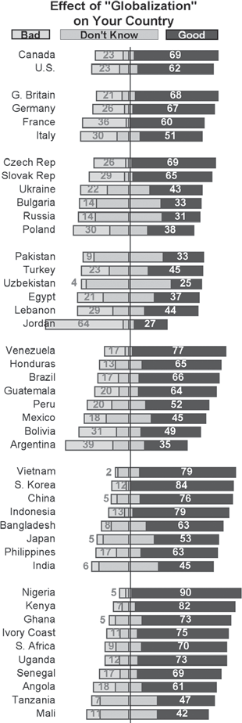
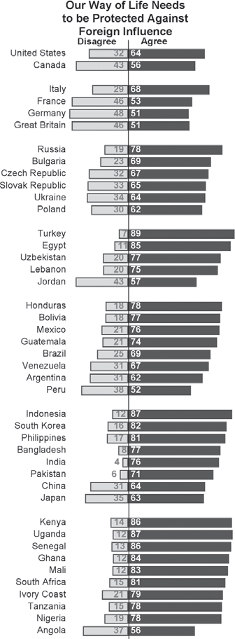
Pew Graphs 3: Globalization

Questions to Consider:
- What information is shown in the graphs?
The Pew Global Attitudes Project. Reprinted with permission.
The Pew Global Attitudes Project. Reprinted with permission.

- The graphs show statistics for different regions of the world. Are there trends within each region? Are there trends between regions?

- Compare the regions across graphs. For example, compare the findings for Eastern European coun- tries in each of the graphs. Are there any surprising results?

- Why do you think so many countries have such large “don’t know” categories?

Pew Graphs 4: Economy and Trade
People Are Better Off in Free Markets

% agree
2002 2007 Change
% %
Canada 61 71 +10
United States 72 70 -2
Argentina 26 43 +17
Mexico 45 55 +10
Venezuela 63 72 +9
Brazil 56 65 +9
Peru 43 47 +4
Bolivia 54 53 -1
Britain 66 72 +6
Italy 71 73 +2
Germany 69 65 -4
France 61 56 -5
Poland 44 68 +24
Bulgaria 31 42 +11
Russia 45 53 +8
Ukraine 64 66 +2
Slovakia 51 53 +2
Czech Rep. 62 59 -3
Jordan 47 47 0
Turkey 60 60 0
Lebanon 76 74 -2
Bangladesh 32 81 +49
India 62 76 +14
Pakistan 50 60 +10
Japan 43 49 +6
China 70 75 +5
South Korea 81 72 -9
Indonesia 54 45 -9
Kenya 67 78 +11
Tanzania 56 61 +5
Ivory Coast 79 80 +1
Ghana 74 75 +1
Nigeria 79 79 0
South Africa 74 74 0
Uganda 73 67 -6

Percent who agree most people are better off in a free market economy, even though some people are rich and some are poor. Includes all countries where trends are available.
A Little Less Enthusiasm for Trade in the West

Trade good
for your country*
2002 2007 Change
% %
Canada 86 82 -4
United States 78 59 -19
Argentina 60 68 +8
Bolivia 77 80 +3
Mexico 78 77 -1
Brazil 73 72 -1
Peru 83 81 -2
Venezuela 86 79 -7
Germany 91 85 -6
Britain 87 78 -9
France 88 78 -10
Italy 80 68 -12
Bulgaria 88 88 0
Poland 78 77 -1
Ukraine 93 91 -2
Slovakia 86 83 -3
Czech Rep. 84 80 -4
Russia 88 82 -6
Jordan 52 72 +20
Lebanon 83 81 -2
Turkey 83 73 -10
Bangladesh 83 90 +7
Pakistan 78 82 +4
China 90 91 +1
India 88 89 +1
Japan 72 72 0
South Korea 90 86 -4
Indonesia 87 71 -16
Kenya 90 93 +3
Ghana 88 89 +1
Tanzania 82 82 0
South Africa 88 87 -1
Ivory Coast 96 94 -2
Nigeria 95 85 -10
Uganda 95 81 -14

* Percent saying trade with other countries is a very or somewhat good thing for their country. Includes all countries where trends are available.

Questions to Consider:
- What information is shown in the tables?
The Pew Global Attitudes Project. Reprinted with permission.
The Pew Global Attitudes Project. Reprinted with permission.

- The tables show statistics for different regions of the world. Look both at the percentages of people who agree and at the change over time. Are there trends within each region? Are there trends between regions?

- Compare the regions across tables. For example, analyze the African countries. What differences and similarities do you notice across the tables?

Changing World
24
Day Two
Name:

Foreign Perceptions of the United States
64 64
52
46
7066
8075
7773
69 67
67
61
81
79
88
87 86
93
29
27
34
19
15
75
70
61
58
59 58
53 51
42
40
38
13
9
78 75
69
62
47
46
36
31
25
21
20
21
15
13
67
61 63
60
56
54
52
45
41
41
51
54
46
73
70
63
62
61
39
34
53
30
51
46
42 43
26
16
64
61 59
55 56
5652
44 45
56
76
55
86
80

* Where the U.S. is mentioned more frequently than any other country or group.
** Revolutionary Armed Forces of Colombia
Figures show the percent who mention each as a potential threat to their country.
al Qaeda 19 Iraq 14
al Qaeda 23 Iran 23
Israel 15 Algeria 15
Gambia 12 al Qaeda 8
Venezuela 8
Venezuela 23
China 20
China 12
Iran 10
Chile 43
Iran 25
Iran 14
Second Third
India 47 Pakistan 32
Japan 63 Taiwan 18
Iraq 13 Russia 9
India 45 Israel 32
China 17 Russia 13
Iran 14 FARC 9** al Qaeda 8 Chile 8
Chechnya 29 al Qaeda 27
Abu Sayyaf 7 North Korea 6
U.S.
72
66
64
64
63
54
52
49
46
45
45
44
32
31
29
17
15
Bangladesh China Turkey Pakistan Indonesia Venezuela Argentina Russia Malaysia Brazil Bolivia Mexico Nigeria Ukraine Spain Morocco Senegal
Countries in Which the U.S. is Viewed as the Greatest Threat*
The Pew Global Attitudes Project. = Reprinted with permission.
The Pew Global Attitudes Project. Reprinted with permission.
The Pew Global Attitudes Project. Reprinted with permission.

Ivory Coast
Kenya Mali Ghana Ethiopia Senegal
S. Africa Nigeria Uganda Tanzania
Japan
S. Korea
India Bangladesh Indonesia Malaysia China Pakistan
Israel Lebanon Kuwait Jordan Egypt Morocco Palest. ter.
Turkey
Ukraine Poland Bulgaria Czech Rep.
Russia Slovakia
Sweden Britain Germany
Italy France Spain
Venezuela
Peru Chile Mexico Brazil Bolivia Argentina
U.S.
Canada
Rating the U.S. and Its People
Favorable views of…
Americ ans America
* Where the U.S. is mentioned more frequently than any other country or group.
Figures show the percent who mention each as a potential threat to their country.
Japan 16
Brazil 19
Argentina 13 China 11
Japan 15
Britain 22
Brazil 30
China 32
S. Arabia 48 Britain 23 Russia 43 Japan 34 Canada 15 EU 15
Third
France 12
EU 29
EU 20
EU 18
China 32
Britain 28
EU 40
China 27
EU 25
France 11
Kenya 24
France 48
Second
Britain 46
China 48
China 26
Britain 51
Britain 56
China 41
China 53
Britain 40
Britain 37
EU 21
Britain 29
China 49
U.S.
87
75
74
69
65
63
58
58
57
57
57
56
54
46
41
38
37
32
23
Israel
South Korea Japan Canada Ghana Kenya Ethiopia Nigeria South Africa Britain Uganda
Mali Kuwait India Mexico Peru Tanzania Brazil Chile
Countries in Which the U.S. is Viewed as the Most Dependable Ally*

Questions to Consider:
- What information is shown in the graph on the left?

- The graph on the left shows statistics for different regions of the world.
  - Are there any trends within regions? Are there any trends between regions?

  - In which regions do people think more favorably of Americans than of the United States? In which regions do people think more favorably of the United States than of Americans?

  - What might be some reasons for these differences?

- Compare the two tables on the right. Is there any surprising information? Why might some coun- tries be listed in both tables?

- Compare the tables on the right with the graph on the left. Are there any surprising results? For ex- ample, are there any countries that have favorable opinions of the United States but also consider the United States to be their greatest threat? Are there countries that have unfavorable opinions of the United States but also consider the United States to be their most dependable ally? Why might this be the case?

Political Cartoons in the Press
Introduction: The strong feelings raised by politics and international issues are the fodder of political cartoonists in this country and around the world. Cartoons not only reflect the events of the times, but they often offer an interpretation or express a strong opinion about these events as well.
The cartoons come from cartoonists in both the United States and abroad.
Answer questions 1-2 in the space beside each cartoon. Questions 3-4 should be answered on a separate sheet of paper.
- Who or what is depicted in the cartoon?
- Does the cartoon have a point of view? What is it?
- Choose two cartoons in the collection which present opposing views. How do the messages differ?
- What strikes you most about this collection of cartoons?

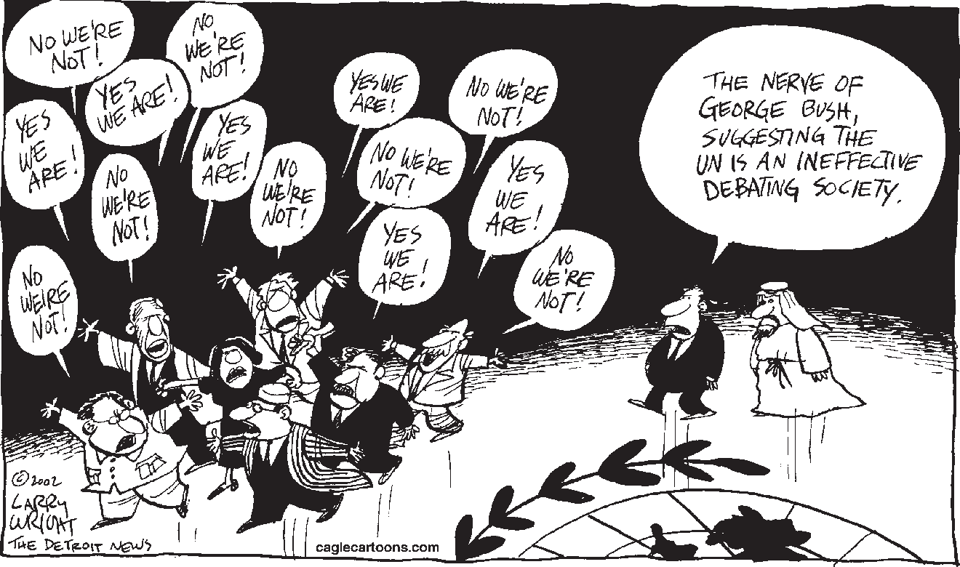
1.
Larry Wright, The Detroit News. Reprinted with permission.

2.

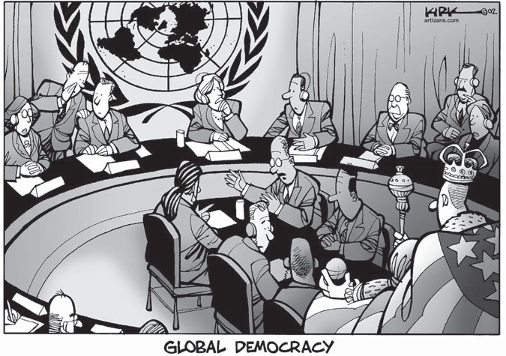
1.

2.
Kirk Anderson. Reprinted with permission from Artizans.com.

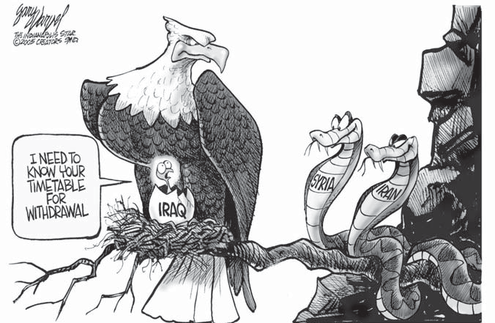
1.
By permission of Gary Varvel and Creators Syndicate, Inc.

2.

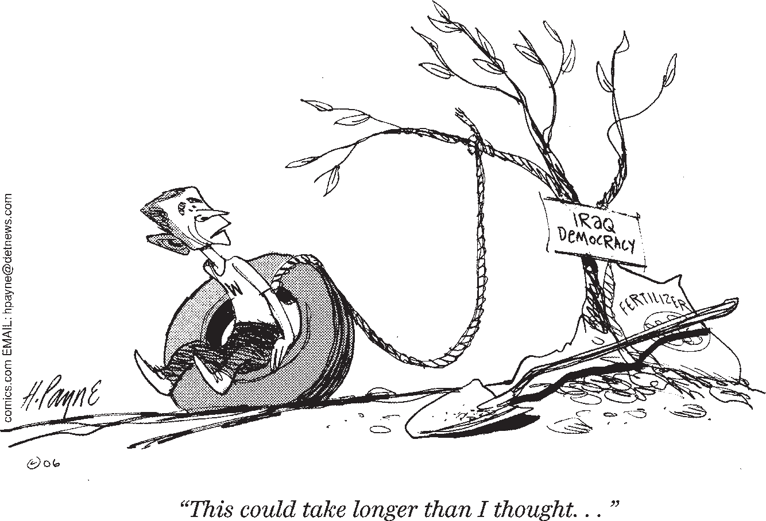
1.
HENRY PAYNE: © Detroit News/Dist. by United Feature Syndicate, Inc.

2.

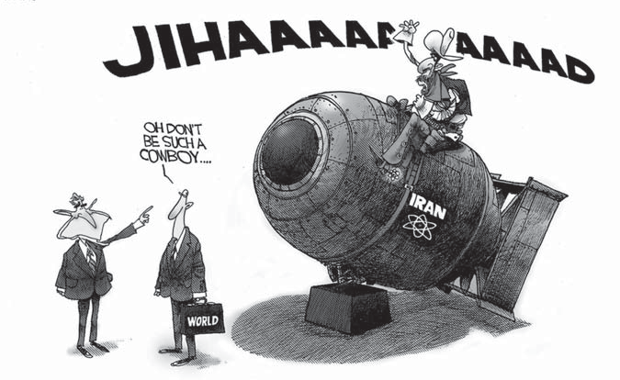
1.
Courtesy of Mike Ramirez and Copley News Service.

2.

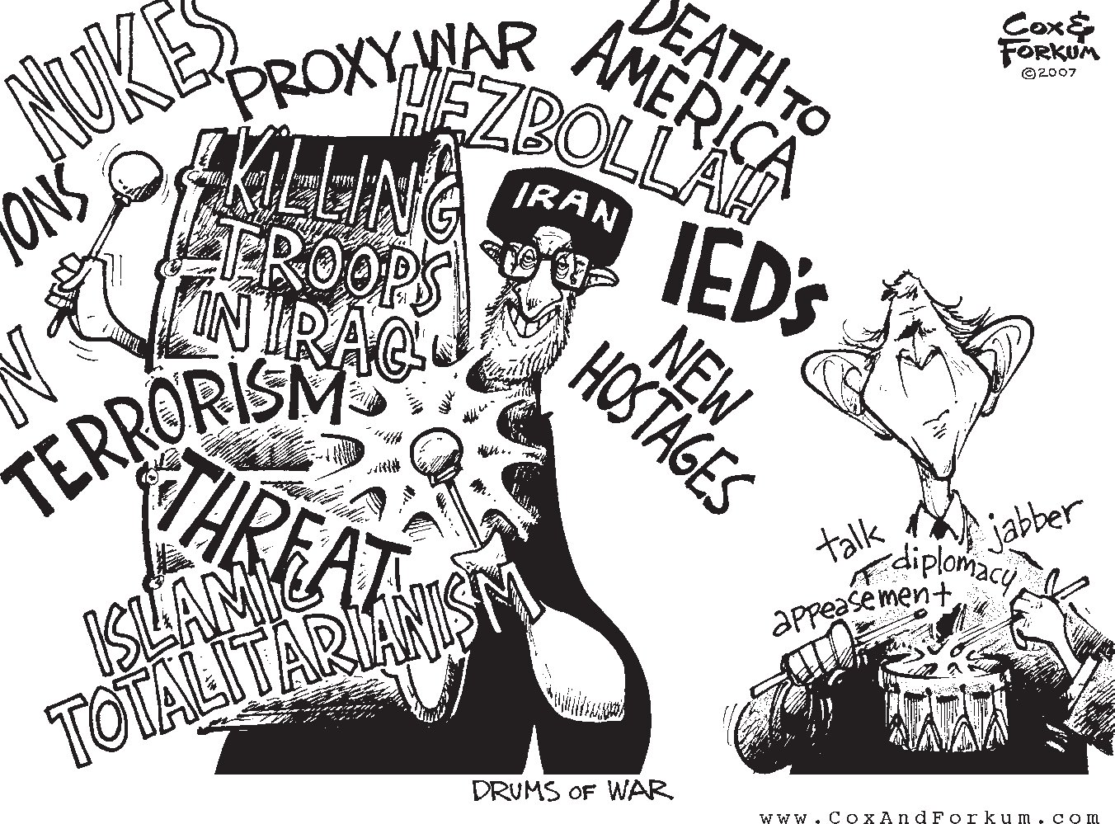
1.

2.
Courtesy of Cox & Forkum.

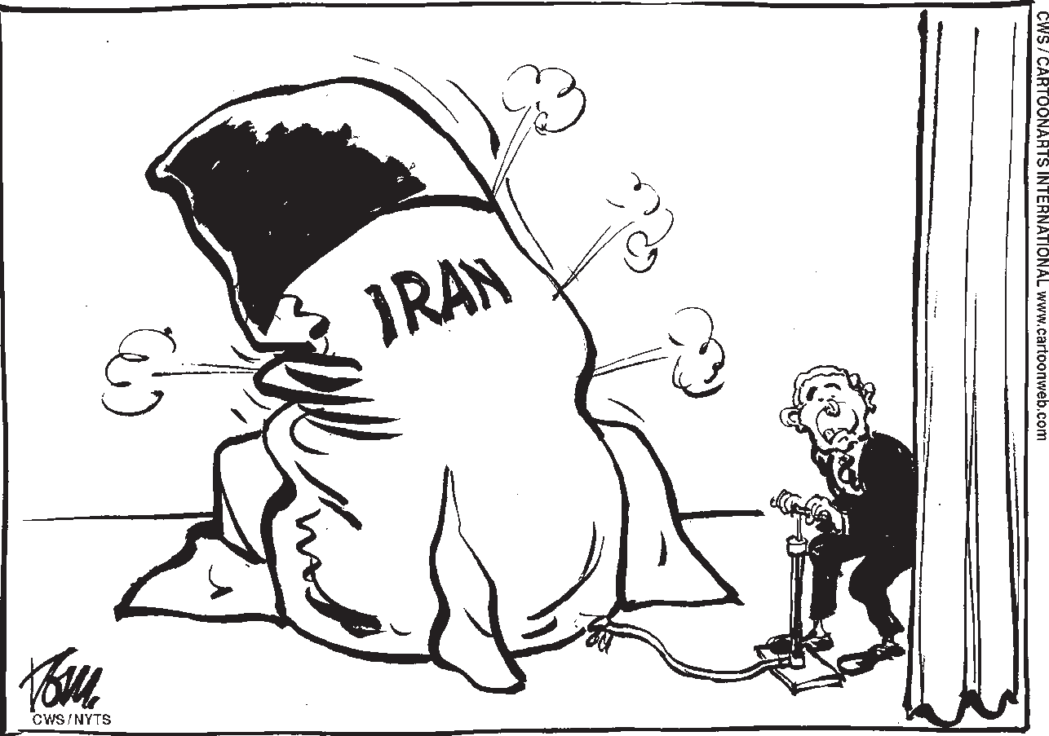
1.
Tom in Trouw, Netherlands. CWS/Cartoonists International. Reprinted with permission.

2.

Changing World
30
Optional Lesson
Name:

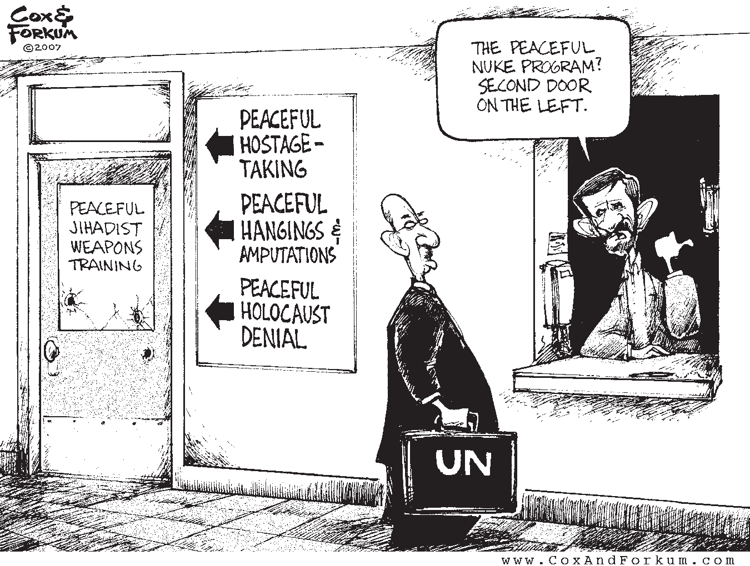
1.

2.
Courtesy of Cox & Forkum.

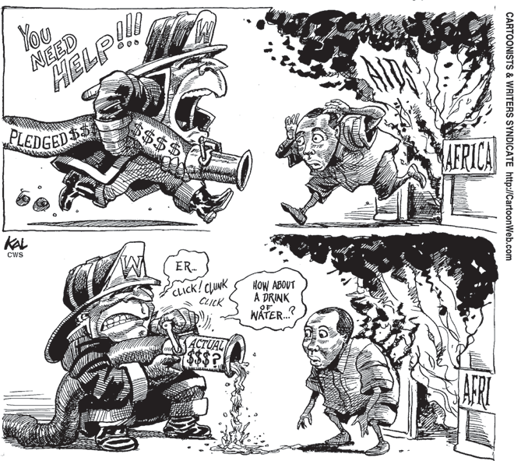
1.
KAL in Baltimore Sun. CWS/Cartoonists International. Reprinted with permission.

2.

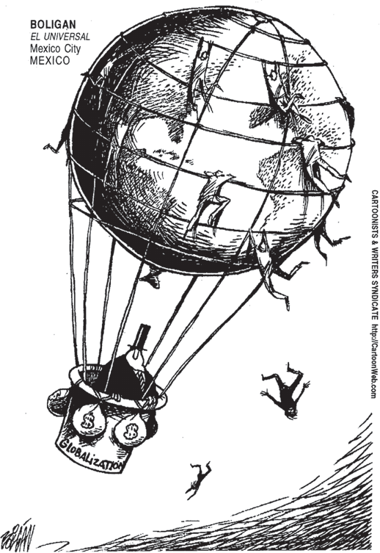
1.

2.
Boligan in El Universal, Mexico. CWS/Cartoonists International. Reprinted with permission.

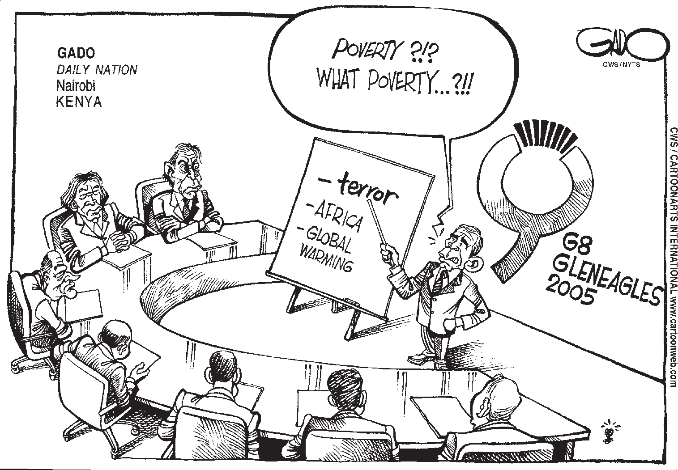
.
Gado in Daily Nation, Kenya. CWS/Cartoonists International. Reprinted with permission.

Study Guide—Part III
- How did the role of the UN change immediately after the Cold War?

- List three ways the 1991 war against Iraq was significant. a.

b.

c.

- Explain how events in Somalia in 1993 influenced American public opinion.

- “The National Security Strategy maintains that the policies of deterrence and

can no longer serve as the only cornerstones of American

policy. The strategy states publicly that the United States will act alone—

—when necessary. The new strategy also endorses military action to address threats even before an against Americans or American infrastructure is .” [Fill in the blanks using your reading.]
- List three supporting arguments for the National Security Strategy. a.

b.

c.

- List three criticisms of the National Security Strategy. a.

b.

c.

- In the dialogue, “Another Look at Preventive War,” what are the three conditions that Sam says need to be met for self-defense to be legal?
a.

b.

c.

Changing World
34
Day Three
Name:

- List three arguments supporting the current war in Iraq. a.

b.

c.

- List three arguments against the war in Iraq. a.

b.

c.

- “Today, various between al Qaeda and other radical forge an international of of cells belonging to different
groups and located on different .” [Fill in the blanks using your reading.]

- What are the three challenges the United States faces regarding nuclear weapons? a.

b.

c.

- What are the Nunn-Lugar Threat Reduction Programs? Have they been successful? Explain.

- List three countries that the United States is most concerned about in terms of nuclear weapons. Give at least one reason for concern.

Country | Reason for Concern

How did historical precedents influence U.S. security policy?

Yugoslavia
Somalia
Gulf War

Summary of security challenge:

Actions taken by the U.S.:

How did the outcome of this event impact U.S. policy on foreign intervention?
Summary of security challenge:

Actions taken by the U.S.:

How did the outcome of this event impact U.S. policy on foreign intervention?
Summary of security challenge:

Actions taken by the U.S.:

How did the outcome of this event impact U.S. policy on foreign intervention?

What is current U.S. security policy?
Supporters say its strengths are:
•
•
•
•
•
•
Critics say its weaknesses are:
•
•
•
•
•
•
U.S. Security Concerns
What current security challenges exist?
Iraq
Summarize the current challenges:

Actions taken by the U.S.:
Terrorism
Summarize the current challenges:

Actions taken by the U.S.:
Nuclear Weapons
Summarize the current challenges:

Actions taken by the U.S.:

Expressing Core Beliefs and Values

The notion of values lies at the heart of this unit. Each of the four Futures in this unit revolves around a distinct set of beliefs that are grounded in core values. The opening paragraphs of your Future make a convincing case for the values that are represented. Each Future also includes a section devoted to iden- tifying the beliefs that shape that Future.
The term “values” is not easy to define. Most often, we think of values in connection with our personal lives. Our attitudes toward our families, friends, and communities are a reflection of our personal values. Values play a critical role in our civic life as well. In the United States, our country’s political system and foreign policy have been shaped by a range of sometimes competing values. The high value many Americans place on freedom,
democracy, and individual liberty rings loudly throughout U.S. history. We are also a country that cares about equality, justice, and the com- monweal (or community). Since World War II, the United States has arguably played a larger role in world affairs than any other nation.
At times, American leaders have emphasized the values of human rights and cooperation. On other occasions, the values of stability and security have been stressed.
Some values fit together well. Others are in conflict. Americans are constantly being forced to choose among competing values in our ongoing debate about foreign policy. Your job is to identify and explain the most impor- tant values underlying your Future and then to outline your Future’s views and policies on the next page.

- What are the two most important values underlying your Future? a.

b.

- According to the values of your Future, what should be the role of the United States in the world?

- Why should the values of your Future serve as the basis for our country’s foreign policy?

Name:
Changing World
Day Three
39

What are this Future’s views on security?

Specific security policy recommendations:
What are this Future’s views on health and enviroment?
Specific health and environment policy recommendations:
What are this Future’s views on culture and values?
Specific culture and values policy recommendations:
What are this Future’s views on economy?
Specific economic policy recommendations:
What are this Future’s views on international relations?
Specific international relations policy recommendations:
Future #
Future Summary:

Committee on Foreign Relations of the U.S. Senate Hearing on U.S. Foreign Policy

Your Role: As a member of the Commit- tee on Foreign Relations of the U.S. Senate, you consider issues relating to our country’s foreign policy. In the past few years, many of our long-standing assumptions about the
world have changed. U.S. foreign policy must keep up with the changes that have taken place. These hearings will introduce you to four distinct positions on our country’s role in the world.
Your Assignment: While the Future groups are organizing their presentations, you should prepare two questions regarding each of the Futures.
Your questions should be challenging and critical. Your purpose is to ask questions that will require those presenting the Futures to clarify the key points. When you have fin- ished, you and your classmates should fully understand each Future being presented. A good question for Future 1 might be:
Wouldn’t Future 1 put us in conflict with some of our most important economic and military allies, such as Saudi Arabia?
You will need to review the readings to analyze the relationship of the Futures to the range of issues facing the United States today. The “opposing arguments” section under each of the four Futures will also be helpful to you as you develop your questions. Your teacher will collect the questions at the end of the hearings.
On Day Four, the four Future groups will present their positions. After their presenta- tions are completed, your teacher will call on you and your fellow committee members to ask questions. The “Evaluation Form” you
will receive is designed for you to record your impressions of the Future groups. Part I should be filled out in class after the Future groups make their presentations. Part II should be completed as homework. After the hearings are concluded, you may be called upon to ex- plain your evaluation of the Future groups.

Changing World
42
Day Four
Name:

Evaluation Form

Committee on Foreign Relations of the U.S. Senate

Part I

What was the most persuasive argument presented in favor of this Future?

Future 1

Future 2

Future 3

Future 4
What was the most persuasive argument presented against this Future?

Future 1

Future 2

Future 3

Future 4

Part II
Which group presented its Future most effectively? Explain your answer.

Changing World
44
Day Five

U.S. Role in the World Student Ballot

You are encouraged to enter your responses to these questions online at <www.choices.edu/ usroleballot>. This is an opportunity to have your views heard beyond the classroom as part of a national ballot.

Part I: Ranking the Futures
Which of the Futures below do you prefer? Rank the Futures, with “1” being the best Future for the United States to follow.
Future 1: Lead the World to Democracy
Future 2: Protect U.S. Global Interests
Future 3: Build a More Cooperative World
Future 4: Protect the U.S. Homeland

Part II: What most concerns you? Please check only three.
1. A clash of ideologies and political values will fuel conflict and instability in the world.
2. The gulf between the developed and developing worlds will widen, making it increasingly dif- ficult to address common problems.
3. Increasing immigration will worsen strains in our society.
4. U.S. jobs will be lost to other countries.
5. Loose border controls will threaten our security.
6. The United States will act unilaterally and the international community will turn against us.
7. Nuclear, biological, and chemical weapons will proliferate and end up in the hands of terror- ists.
8. The United States will drain its resources trying to solve other countries’ problems.
9. The United States will lose access to oil and other key resources abroad.
10. U.S. troops will get bogged down in conflicts abroad.
11. Damage to the global environment will become irreparable.
12. More Americans will die at the hands of terrorists.
13. Participation in international organizations will force the U.S. to follow costly or risky poli- cies.

Part III: What beliefs drive your thinking?
Rate each of the statements below according to your personal beliefs:
1 = Strongly Support; 2 = Support; 3 = Oppose; 4 = Strongly Oppose; 5 = Undecided
In today’s interconnected world, many serious problems can be addressed only through interna- tional cooperation.
We will always have to compete with the world’s other nations for power.
Any nation acting alone has neither the moral authority nor the capacity to right the world’s wrongs.

The United States should not do business with countries that grossly abuse the human rights of their citizens.
Our resources should be focused on addressing poverty, crime, and budget deficits at home.
We have no right to decide on our own to pressure another country to behave in a certain way.
The greatest threat to our civil liberties comes from the limits we put on ourselves because of our fear of others.
Using our economic and military power around the world creates more enemies than friends.
Trying to make deep changes in the way the world works is naive and dangerous.
As Americans, we have a responsibility to spread democracy around the world.
Free trade and open economies are the best way to foster economic growth at home and around the world.

Part IV: What should we do?
Rate each of the statements below according to your beliefs:
1 = Strongly Support; 2 = Support; 3 = Oppose; 4 = Strongly Oppose; 5 = Undecided
The United States should spend what is necessary to remain a military superpower, even if this means having less domestic spending, larger deficits, or higher taxes than we would like.
The United States should support broadening the mandate of the UN and other international or- ganizations, even if this means we are bound by the decisions of this community of nations and cannot act unilaterally except to defend our homeland.
The United States should use military force to protect access to oil and other important raw materials, even if this places us in opposition to our traditional allies and the broader inter- national community.
The United States should commit itself to the elimination of nuclear weapons, even if this means that we will need to rethink our defense strategy.
The United States should impose trade sanctions on countries that threaten their neighbors with aggression or contribute to the proliferation of nuclear weapons, even if such sanctions harm U.S. trade relations.
The United States should increase financial aid to countries where poverty and despair are creat- ing the breeding grounds of discontent, even if money needs to be diverted from domestic programs.
The United States should help negotiate strict international standards to address global warming and other environmental threats, even if compliance forces us to pay more for cars, gaso- line, and other products that contribute to pollution.
The United States should accept fewer immigrants, in addition to cracking down on illegal im- migration, even if this deprives the American work force of the talent and ambitions of newcomers and fuels anti-American sentiment abroad.
The United States should use its military—alone if necessary—to stop gross human rights viola- tions, even if this may isolate us from our traditional allies or the broader international community.

Changing World
46
Day Five
Name:

Creating Your Future Five

Instructions: Having completed your U.S. Role in the World Student Ballot and submitted it on- line at <www.choices.edu/usroleballot>, you are ready to offer your own recommendations for U.S. foreign policy. In this exercise you will create a Future that reflects your own beliefs and opinions. You may borrow heavily from one Future, combine ideas from two or three Futures, or take a new approach altogether. Be careful of contradictions, keep in mind that policies should logically follow beliefs, and remember that the economic cost of your Future must be factored into your thinking.
There are no right or wrong answers. Rather, you should strive to craft a Future that is logical and persuasive.

Your Future Five: (your title)
- What do you believe are the most important problems facing the United States?

- What steps in the foreign policy arena should the United States take over the next ten years?

- How would your Future affect the lives of Americans? How would your Future affect the lives of people in other countries?

- What are the two strongest arguments opposing your Future? a.

b.

- What are the two strongest arguments supporting your Future? a.

b.

Key Terms

Introduction and Part I
values independence colonial powers annexation nationalist
self-rule neutrality
international cooperation

territorial integrity imperial interests communism fascism international order nuclear weapons containment deterrence

Part II
democracy free market
interdependence economic refugees Americanization WTO
NAFTA
bilateral GDP
employment security developing economies

Part III
security rule of law genocide
humanitarian intervention human rights violations military intervention rogue states

inequality
per capita income HIV/AIDS
malaria malnutrition climate change
Northern and Southern countries “green” technology
capitalism UN

unilateral preemption preventive war regime
collective security multilateral

diplomacy political instability
international governmental organization
The World Bank IMF
democratization NGO
value system religious extremism

WMD ICBM
national missile defense proliferation
hair-trigger economic sanctions

Issues Toolbox

Imperialism:
The policy of extending the rule of a na- tion over foreign countries as well as acquiring colonies and dependencies.
At the end of the nineteenth century, sup- porters of imperialism by the United States used several different arguments to advocate their point of view. A school of thought led by naval Captain Alfred Thayer Mahan stressed the importance of naval power for the United States’ physical and economic security. This meant that the United States would need to acquire and maintain naval bases around the globe.
Others drew from Darwinian theory and suggested that there was a struggle between nations and people in which only the fittest would survive. They believed that the Anglo- Saxon race and particularly Americans were best-suited to spread their religious, cultural, and civic values throughout the world.
Senator Alfred J. Beveridge of Indiana stressed the economic benefits of imperialism and believed that Americans were obligated to govern others who were not able to govern themselves.

Cold War:
The Cold War was the dominant foreign policy problem for the United States and Russia between the late 1940s and the late 1980s. Following the defeat of Hitler in 1945, Soviet-U.S. relations began to deteriorate. The United States adopted a policy of containing the spread of Soviet communism around the world, which led to, among other things, U.S. involvement in Vietnam. During this period both Russia and the United States devoted vast resources to their military, but never engaged in direct military action against each other.
Because both the Soviet Union and the United States had nuclear weapons and were in com- petition around the world, nearly every foreign policy decision was intricately examined for its potential impact on U.S.-Soviet relations.
The end of the Cold War forced policy makers to struggle to define a new guiding purpose for their foreign policy.

Human Rights:
Equal and inalienable rights for all mem- bers of the human family. After the horrors of World War II, nations initiated efforts to develop international standards to protect people from individuals, groups, or nations. There is debate at home and abroad about the nature and scope of human rights. Some believe that human rights exist to protect
individuals’ civil and political freedoms. Civil and political rights include the right to life, liberty and personal security, freedom from slavery, torture and arbitrary arrest, as well as the rights to a fair trial, free speech, free move- ment, and privacy. Others have argued that there are economic, social, and cultural rights as well. These include economic rights related to work, fair pay, and leisure; social rights concerning an adequate standard of living for health, well-being, and education; and the right to participate in the cultural life of the community. International consensus is grow- ing that human rights should encompass the full spectrum spanned by these viewpoints.

Diplomatic Relations:
A formal arrangement between states by which they develop and maintain the terms of their relationship. This often in- cludes establishing treaties regarding trade
and investment, the treatment of each other’s citizens, and the nature of their security rela- tionship. It also includes the establishment of an embassy and consuls in each other’s coun- tries to facilitate representation on issues of concern for each nation.

Sovereignty:
The absolute right of a state to govern itself. The UN Charter prohibits external in- terference in the internal affairs of a sovereign state without the state’s consent.

Sovereignty means freedom from external control. Traditionally, governments, whether they be headed by democratically elected officials or self-imposed dictators—have strongly defended the principle of sovereignty. Sovereignty has served as the foundation of international organizations. Governments have supported the UN, the League of Nations, and earlier international efforts based on the assumption that their sovereignty would be protected. In practical terms, sovereignty has never been absolute. Strong countries have always influenced the policies of weaker countries. The United States, for example, has
long had a hand in shaping the foreign policies and economic development of Latin American nations.
In recent decades, sovereign states have faced pressure from two levels. From above, the principle of sovereignty has been eroded by forces and institutions that extend beyond national boundaries. The growth of world trade, multinational corporations, and even international environmental organizations has forced governments to accept limits on their sovereignty. Brazil, for example, has taken steps to improve conditions for indigenous people in the Amazon region and to curb the destruction of the rainforest in part because
of worldwide concern. Meanwhile, state sovereignty has increasingly been challenged from below by minority groups and regional interests. In Russia, for example, the cen-
tral government has signed agreements with regional leaders to broaden local control over economic affairs.

